Model I EX 요구사항

* Customer 관련 :회원가입, 로그인, 정보수정, 로그아웃, 회원리스트보기
* 고객센터(파일첨부게시판) – 글쓰기, 답변글쓰기, 글목록(페이징추가), 글수정, 글 삭제
* 도서등록, 도서리스트보기(페이징), 도서상세보기
* 로그인한 사람만 도서등록을 할 수 있고, 글쓰기가 가능하다
* 글수정은 내가 쓴 글만 수정 가능하다.
* header의 gnb와 footer의 배경색은 #003300

실행화면 캡쳐

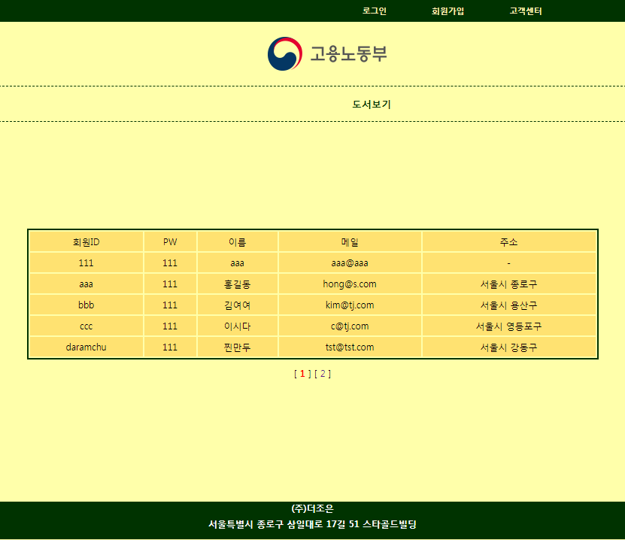 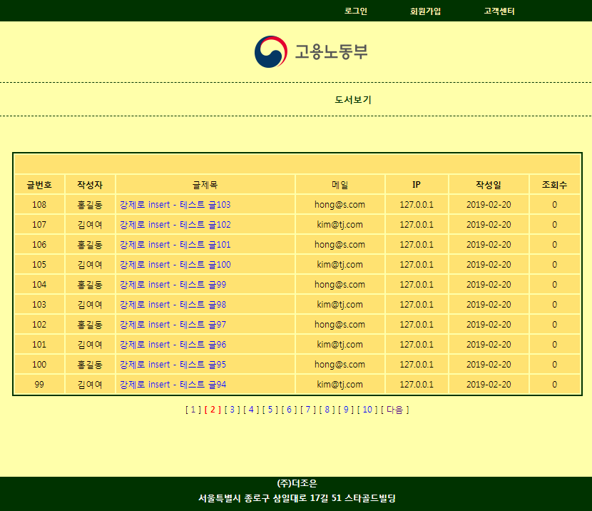

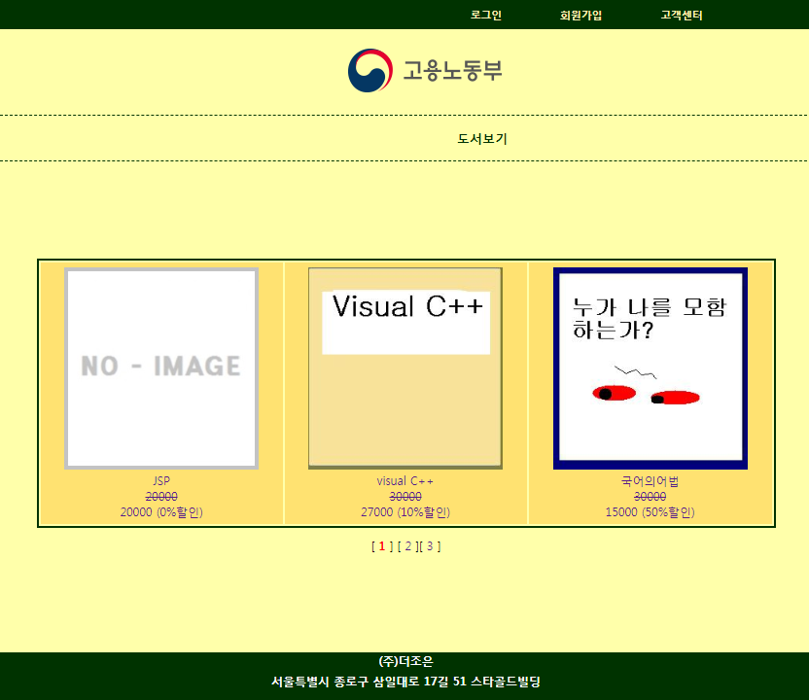 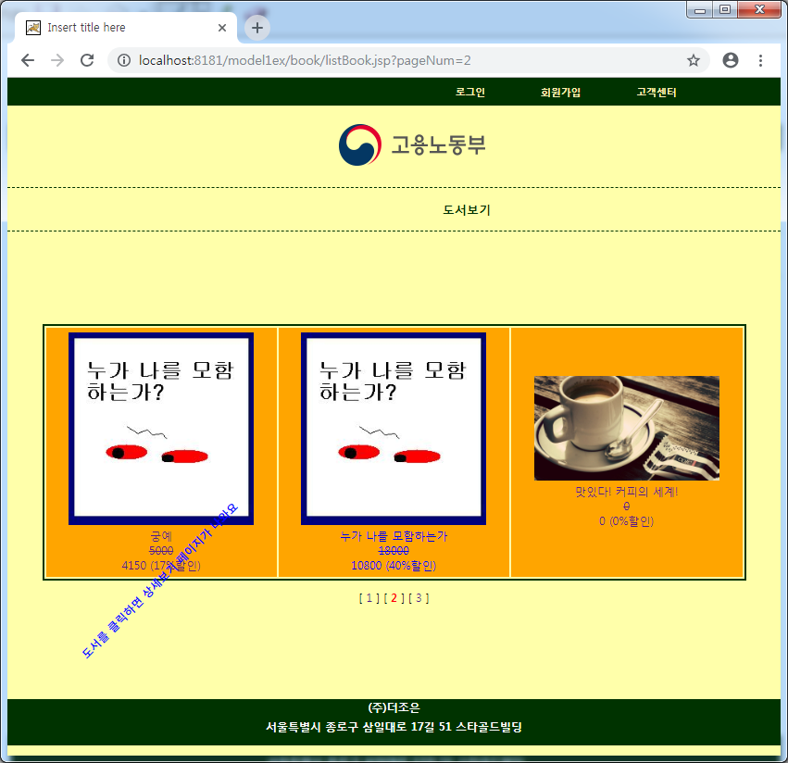

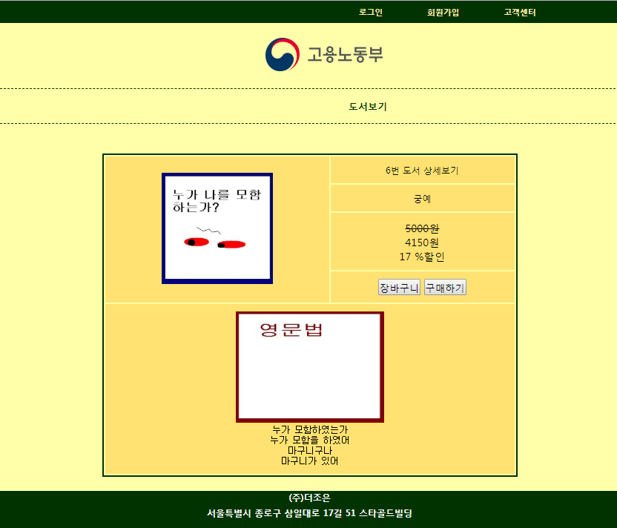 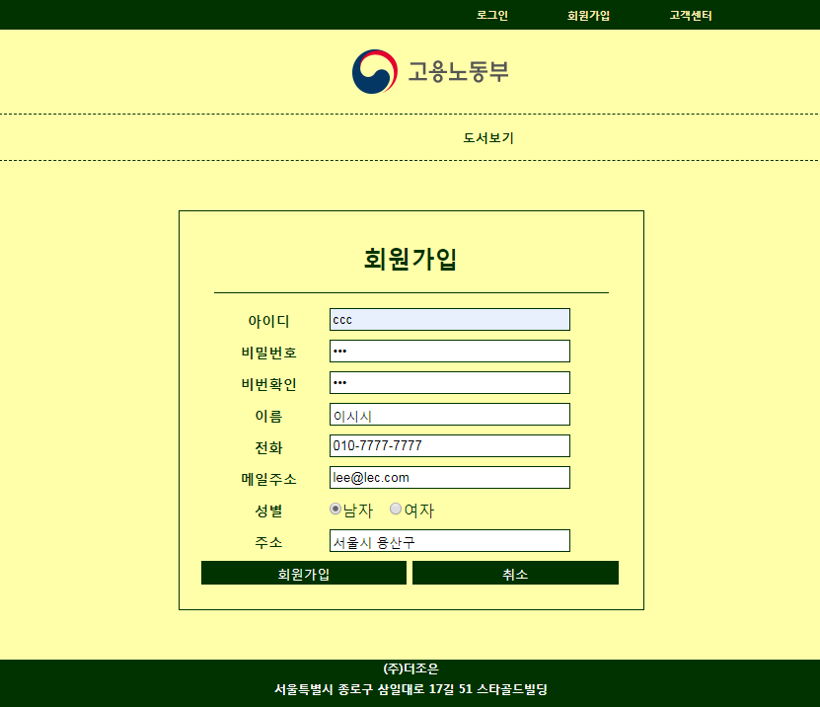

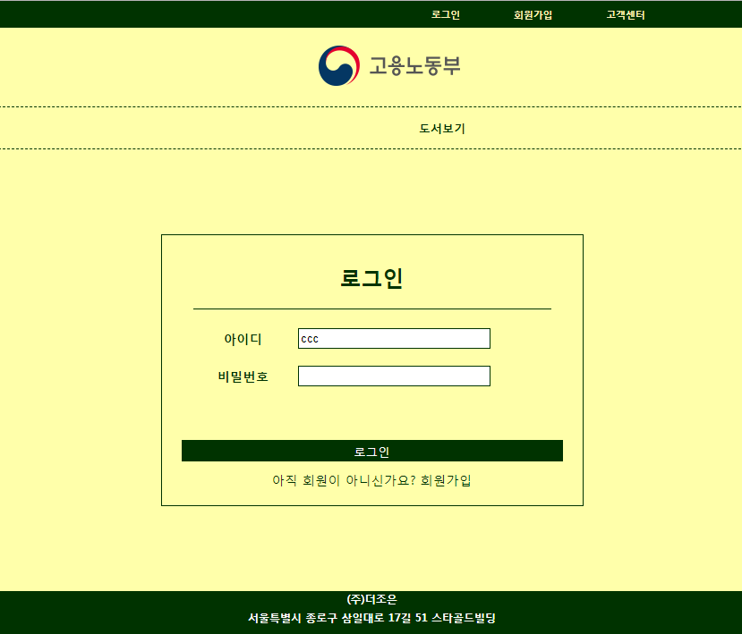 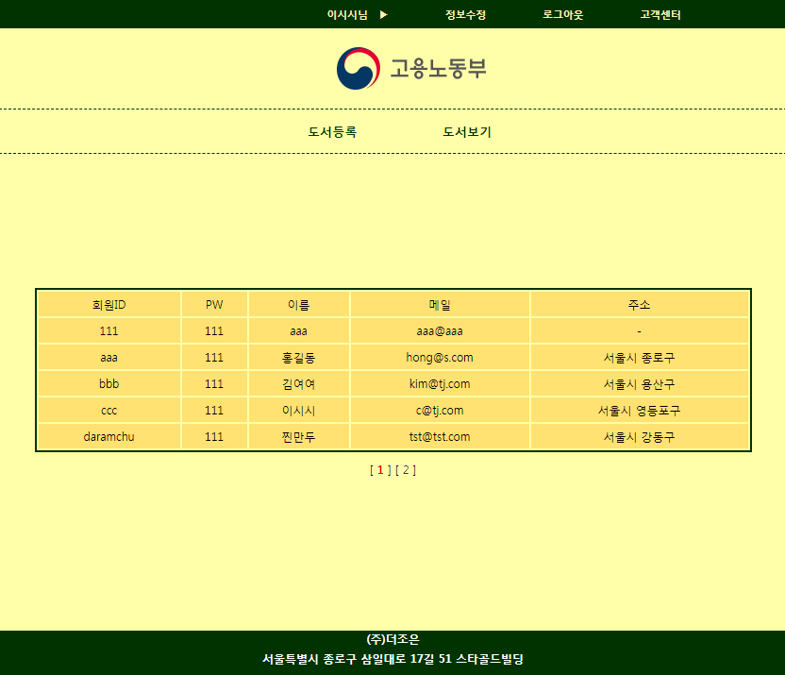

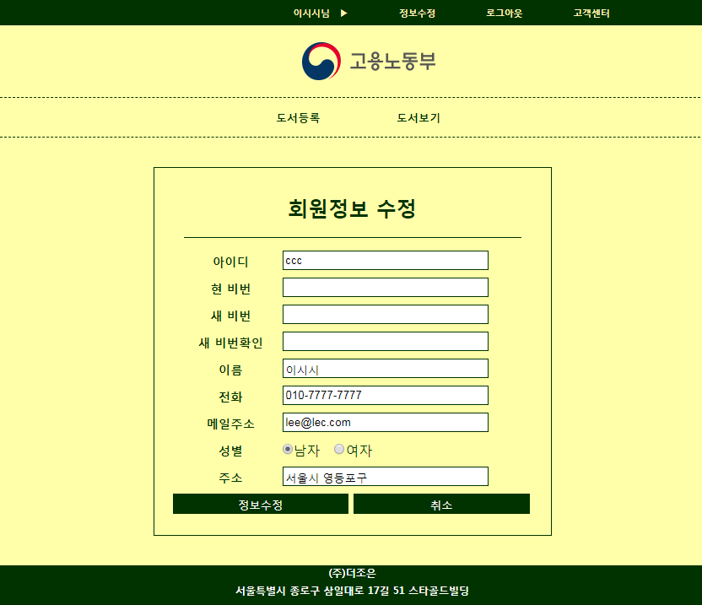 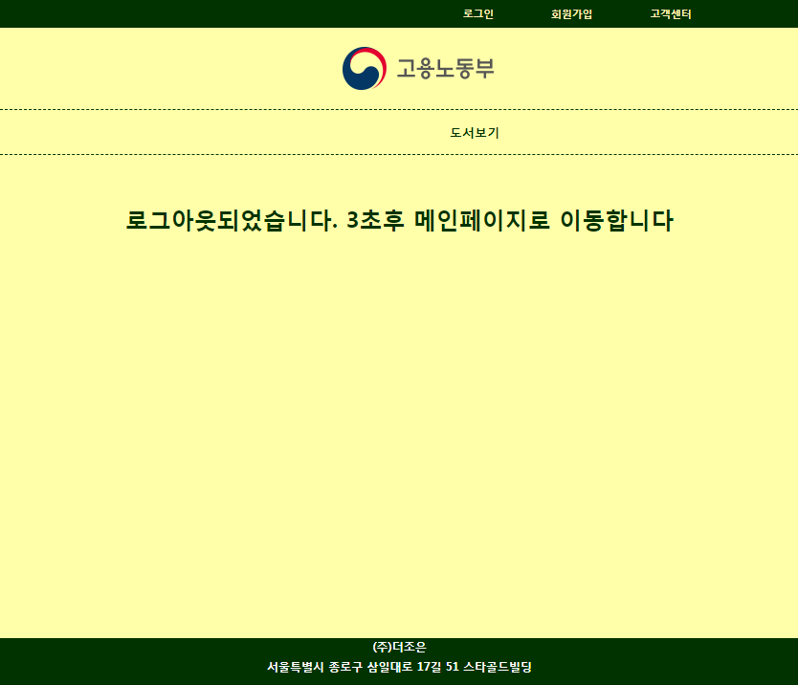

 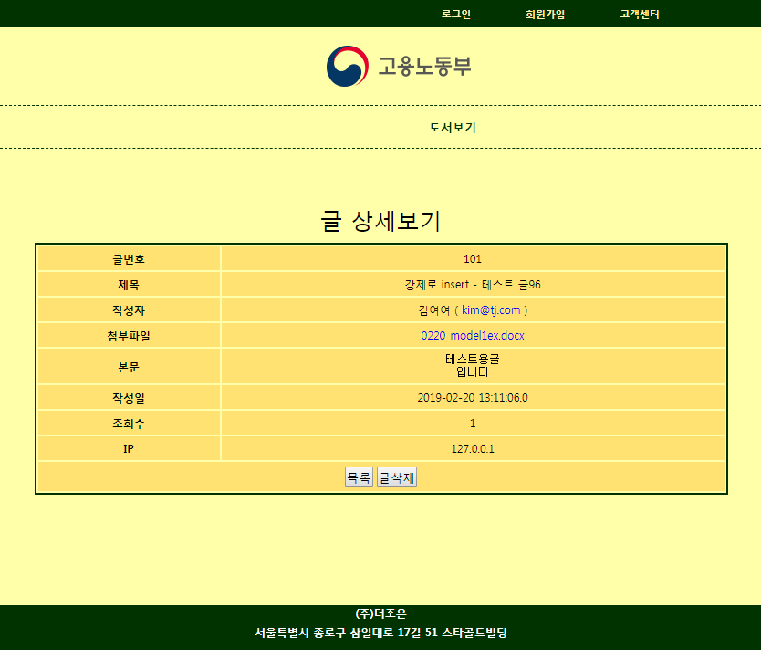

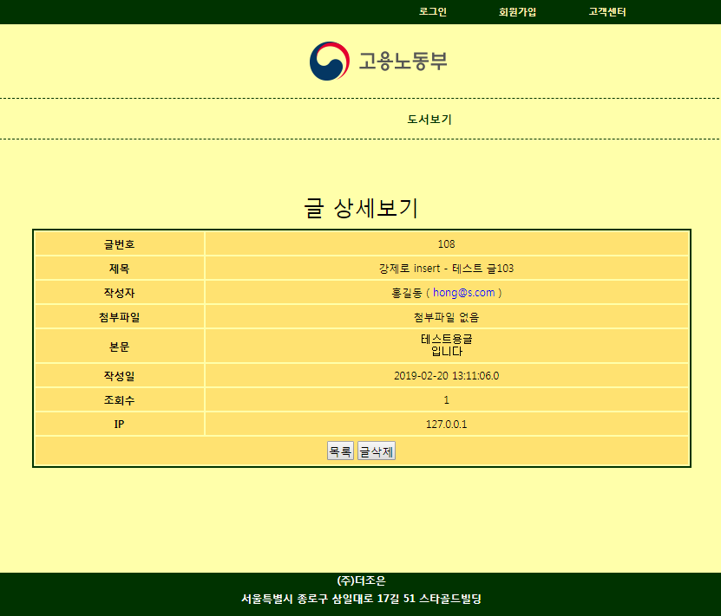 ←첨부파일이 없을 경우 “첨부파일 없음”라고 출력

로그인 한 후 고객센터 게시판 : 글쓰기 가능(로그인전엔 글쓰기 불가), 수정(본인 글만 수정), 답변(로그인 후), 삭제(비번알면 타인글도 로그인 전도 가능).

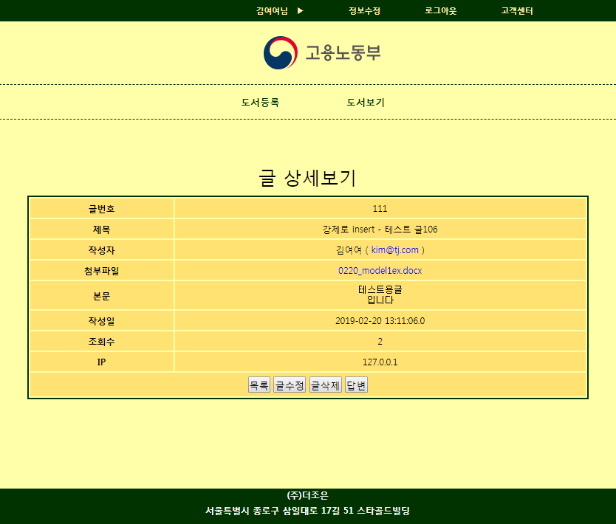 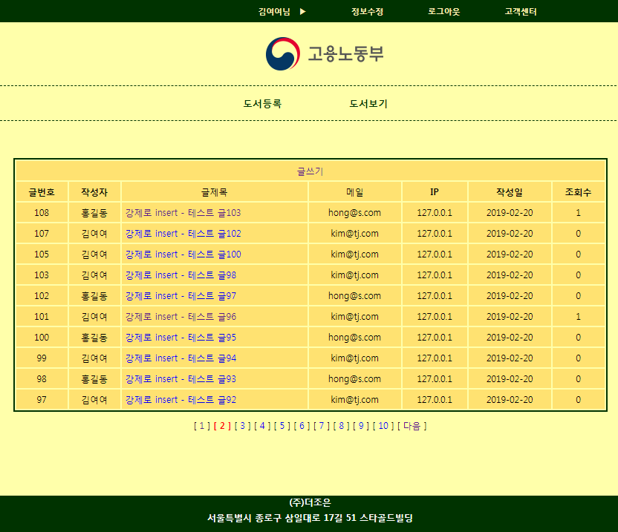

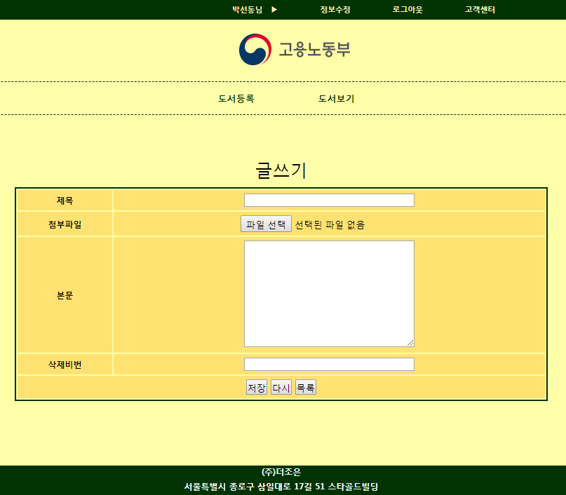 ← 작성자는 session의 cid로

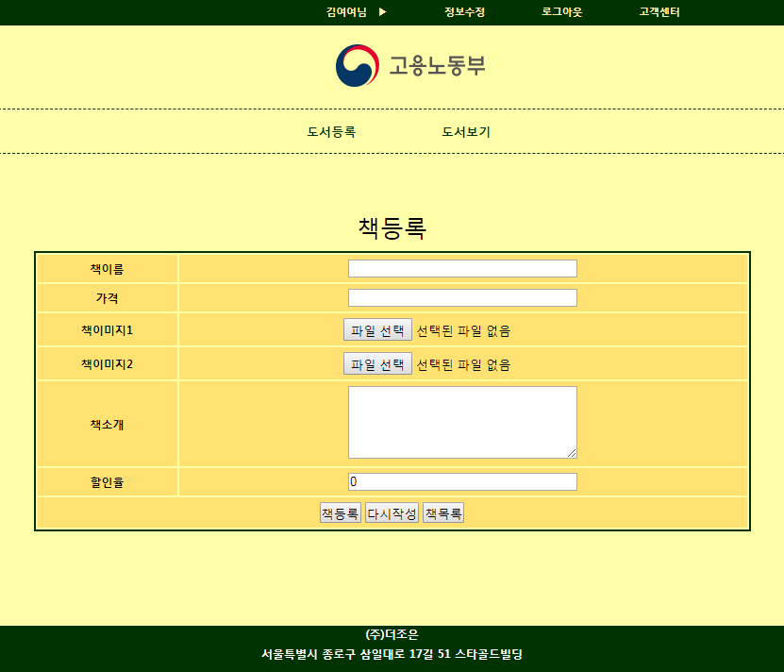 ← 도서등록은 로그인 후에만 가능

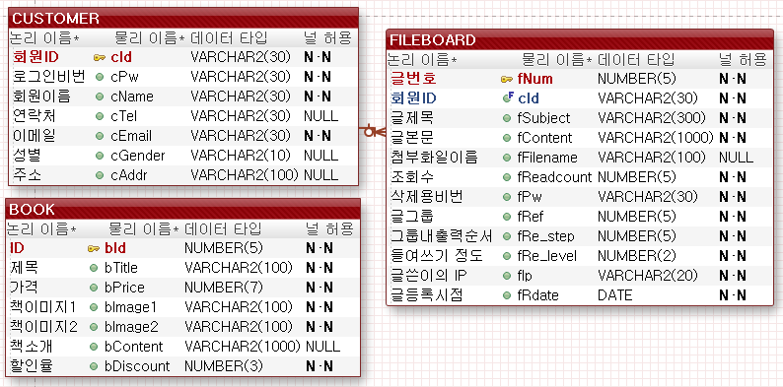

DROP SEQUENCE BOOK_SEQ;

CREATE SEQUENCE BOOK_SEQ MAXVALUE 99999 NOCACHE NOCYCLE;

DROP TABLE BOOK;

CREATE TABLE BOOK(

bId NUMBER(5) PRIMARY KEY,

bTitle VARCHAR2(100) NOT NULL,

bPrice NUMBER(10) NOT NULL,

bImage1 VARCHAR2(100) DEFAULT 'nothing.jpg',

bImage2 VARCHAR2(100) DEFAULT 'nothing.jpg',

bContent VARCHAR2(1000),

bDiscount NUMBER(3));

-- 책 등록

INSERT INTO BOOK (bId, bTitle, bPrice, bImage1, bImage2, bContent, bDiscount)

VALUES (BOOK_SEQ.NEXTVAL, 'JSP', 20000, 'nothing.jpg','nothing.jpg','좋은책',0);

INSERT INTO BOOK (bId, bTitle, bPrice, bImage1, bContent, bDiscount)

VALUES (BOOK_SEQ.NEXTVAL, 'jQuery', 20000, 'nothing.jpg','좋은jQuery',0);

INSERT INTO BOOK (bId, bTitle, bPrice, bImage2, bContent, bDiscount)

VALUES (BOOK_SEQ.NEXTVAL, 'Spring', 20000, 'nothing.jpg','좋은Spring',0);

INSERT INTO BOOK (bId, bTitle, bPrice, bContent, bDiscount)

VALUES (BOOK_SEQ.NEXTVAL, 'UI test', 20000, '좋은 test',0);

-- 전체 등록된 책 갯수

SELECT COUNT(*) FROM BOOK;

-- 전체 책 출력

SELECT * FROM BOOK ORDER BY bTitle;

-- stratRow ~ endRow까지 책 출력(PAGING)

SELECT * FROM BOOK ORDER BY bTitle; -- 1단계

SELECT ROWNUM RN, A.* FROM (SELECT * FROM BOOK ORDER BY bTitle) A; -- 2단계

SELECT * FROM (

SELECT ROWNUM RN, A.* FROM (SELECT * FROM BOOK ORDER BY bTitle) A)

WHERE RN BETWEEN 2 AND 3;

-- 특정책의 상세보기

SELECT * FROM BOOK WHERE BID=5;

commit;

DROP TABLE FILEBOARD;

DROP TABLE CUSTOMER;

CREATE TABLE CUSTOMER(

cId VARCHAR2(30) PRIMARY KEY,

cPw VARCHAR2(30) NOT NULL,

cName VARCHAR2(30) NOT NULL,

cTel VARCHAR2(30),

cEmail VARCHAR2(30) NOT NULL,

cGender VARCHAR2(10),

cAddr VARCHAR2(100));

DROP SEQUENCE FILEBOARD_SEQ;

CREATE SEQUENCE FILEBOARD_SEQ MAXVALUE 99999 NOCACHE NOCYCLE;

CREATE TABLE FILEBOARD(

fNum NUMBER(5) PRIMARY KEY,

cId VARCHAR2(30),

fSubject VARCHAR2(300) NOT NULL,

fContent VARCHAR2(1000) NOT NULL,

fFilename VARCHAR2(100),

fReadcount NUMBER(5) NOT NULL,

fPw VARCHAR2(30) NOT NULL,

fRef NUMBER(5) NOT NULL,

fRe_step NUMBER(5) NOT NULL,

fRe_level NUMBER(2) NOT NULL,

fIp VARCHAR2(20) NOT NULL,

fRdate DATE NOT NULL,

FOREIGN KEY(cId) REFERENCES CUSTOMER(cId));

-- CustomerDao의 confirmId와 회원가입

SELECT * FROM CUSTOMER WHERE CID='aaa';

INSERT INTO CUSTOMER (cid, cpw, cname, ctel, cemail, cgender, caddr)

VALUES ('aaa','111','홍길동','9999-9999','hong@tj.com','m','서울시 종로');

commit;

-- 메인화면에서 쓸 회원정보 리스트(페이징에서 회원수 가져오기)

SELECT COUNT(*) FROM CUSTOMER;

-- 메인화면에서 쓸 회원정보 리스트(페이징 안되는거)

SELECT * FROM CUSTOMER ORDER BY CID;

-- 메인화면에서 쓸 회원정보 리스트(페이징 되는 거 만들어보자)

SELECT ROWNUM RN, A.* FROM

(SELECT * FROM CUSTOMER ORDER BY CID) A;

SELECT * FROM

(SELECT ROWNUM RN, A.* FROM

(SELECT * FROM CUSTOMER ORDER BY CID) A)

WHERE RN BETWEEN 2 AND 3;

-- CustomerDao의 로그인, 중복체크, 회원정보 수정시 dto가져오기

SELECT * FROM CUSTOMER WHERE CID='aaa';

-- CustomerDao의 회원정보 수정

UPDATE CUSTOMER SET CPW='111', CNAME='홍길동',

CTEL='010-9999-9999', CEMAIL='hong@s.com', CGENDER='f',

CADDR='서울시 종로구' WHERE CID='aaa';

commit;

-- FILEBoardDao의 글갯수 리턴

SELECT COUNT(*) TOTCNT FROM FILEBOARD;

-- FILEBoardDao의 글 입력

INSERT INTO FILEBOARD VALUES (FILEBOARD_SEQ.NEXTVAL, 'aaa','제목','본문\n입니다',

NULL,0,'11',fileboard_seq.CURRVAL, 0,0,'127.0.0.1',SYSDATE);

-- 답변글 추가 전 해야할 ⓐ STEP

UPDATE FILEBOARD SET FRE_STEP = FRE_STEP+1 WHERE FREF=1 AND FRE_STEP>0;

-- 글 갯수

SELECT COUNT(*) TOTCNT FROM FILEBOARD;

-- FILEBoardDao의 글목록

SELECT F.*, C.CNAME, C.CEMAIL FROM FILEBOARD F, CUSTOMER C

WHERE F.CID=C.CID ORDER BY FNUM DESC;

SELECT ROWNUM RN, A.* FROM

(SELECT F.*, C.CNAME, C.CEMAIL FROM FILEBOARD F, CUSTOMER C

WHERE F.CID=C.CID ORDER BY FNUM DESC) A;

SELECT *

FROM (SELECT ROWNUM RN, A.* FROM

(SELECT F.*, C.CNAME, C.CEMAIL FROM FILEBOARD F, CUSTOMER C

WHERE F.CID=C.CID ORDER BY fref DESC, fre_step) A)

WHERE RN BETWEEN 2 AND 4; -- 페이징처리에서 쓸 TOP-N구문

-- FILEBoardDao의 글 상세보기

UPDATE FILEBOARD SET FREADCOUNT = FREADCOUNT + 1 WHERE FNUM=1;

SELECT F.*, C.CNAME, C.CEMAIL FROM FILEBOARD F, CUSTOMER C

WHERE F.CID=C.CID AND F.FNUM=11;

SELECT F.*, C.CNAME, C.CEMAIL FROM FILEBOARD F, CUSTOMER C

WHERE F.CID=C.CID ;

-- 글 수정

UPDATE FILEBOARD SET

FSUBJECT = 'TITLE',

FFILENAME = NULL,

FCONTENT = 'CONTENT',

FPW = '11',

FIP = '127.0.0.1'

WHERE FNUM = 1;

DELETE FROM FILEBOARD WHERE FNUM=111 AND FPW='11';

SELECT F.*, C.CNAME, C.CEMAIL FROM FILEBOARD F, CUSTOMER C

WHERE F.CID=C.CID;

COMMIT;

프로젝트 구성요소

* DTO3개(BookDto,CustomerDto,FileboardDto), DAO 3개(BookDao,CustomerDao,FileboardDao)는 src폴더에 아래의 폴더는 WebContent폴더에
* img 폴더 - 이 프로그램에서 필요한 이미지들(로고, hot.gif, level.gif, re.gif)
* main 폴더 - footer.jsp
* header.jsp
* main.jsp(첫화면)
* customer폴더 - joinForm.jsp
  + - * + joinPro.jsp
        + loginForm.jsp
        + loginPro.jsp
        + logout.jsp
        + modifyForm.jsp
        + modifyPro.jsp
* book폴더 - bookList.jsp
  + - * bookRegister.jsp
      * bookRegisterPro.jsp
      * bookContent.jsp
* bookImg폴더 - 도서등록시 업로드할 파일들이 저장될 폴더
* fileboard폴더 – fboardList.jsp
  + - * + fboardContent.jsp
        + fboardDeleteForm.jsp
        + fboardDeletePro.jsp
        + fboardUpdateForm.jsp
        + fboardUpdatePro.jsp
        + fboardWriteForm.jsp
        + fboardWritePro.jsp
* fileboardUpload 폴더- 파일첨부게시판에서 첨부한 파일들이 저장될 폴더
* 그 외 css

**(BootDto.java)**

**package** com.tj.model1ex.dto;

**public** **class** BookDto {

**private** **int** bid;

**private** String btitle;

**private** **int** bprice;

**private** String bimage1;

**private** String bimage2;

**private** String bcontent;

**private** **int** bdiscount;

**public** BookDto() {}

**public** BookDto(**int** bid, String btitle, **int** bprice, String bimage1, String bimage2, String bcontent, **int** bdiscount) {

**this**.bid = bid;

**this**.btitle = btitle;

**this**.bprice = bprice;

**this**.bimage1 = bimage1;

**this**.bimage2 = bimage2;

**this**.bcontent = bcontent;

**this**.bdiscount = bdiscount;

}

**public** **int** getBid() {**return** bid;}

**public** **void** setBid(**int** bid) {**this**.bid = bid;}

**public** String getBtitle() {**return** btitle;}

**public** **void** setBtitle(String btitle) {**this**.btitle = btitle;}

**public** **int** getBprice() {**return** bprice;}

**public** **void** setBprice(**int** bprice) {**this**.bprice = bprice;}

**public** String getBimage1() {**return** bimage1;}

**public** **void** setBimage1(String bimage1) {**this**.bimage1 = bimage1;}

**public** String getBimage2() {**return** bimage2;}

**public** **void** setBimage2(String bimage2) {**this**.bimage2 = bimage2;}

**public** String getBcontent() {**return** bcontent;}

**public** **void** setBcontent(String bcontent) {**this**.bcontent = bcontent;}

**public** **int** getBdiscount() {**return** bdiscount;}

**public** **void** setBdiscount(**int** bdiscount) {**this**.bdiscount = bdiscount;}

@Override

**public** String toString() {

**return** "BookDto [bid=" + bid + ", btitle=" + btitle + ", bprice=" + bprice + ", bimage1=" + bimage1

+ ", bimage2=" + bimage2 + ", bcontent=" + bcontent + ", bdiscount=" + bdiscount + "]";

}

}

**(CustomerDto.java)**

**package** com.tj.model1ex.dto;

**public** **class** CustomerDto {

**private** String cid;

**private** String cpw;

**private** String cname;

**private** String ctel;

**private** String cemail;

**private** String cgender;

**private** String caddr;

**public** CustomerDto() { }

**public** CustomerDto(String cid, String cpw, String cname, String ctel, String cemail, String cgender, String caddr) {

**this**.cid = cid;

**this**.cpw = cpw;

**this**.cname = cname;

**this**.ctel = ctel;

**this**.cemail = cemail;

**this**.cgender = cgender;

**this**.caddr = caddr;

}

**public** String getCid() {**return** cid;}

**public** **void** setCid(String cid) {**this**.cid = cid;}

**public** String getCpw() {**return** cpw;}

**public** **void** setCpw(String cpw) {**this**.cpw = cpw;}

**public** String getCname() {**return** cname;}

**public** **void** setCname(String cname) {**this**.cname = cname;}

**public** String getCtel() {**return** ctel;}

**public** **void** setCtel(String ctel) {**this**.ctel = ctel;}

**public** String getCemail() { **return** cemail;}

**public** **void** setCemail(String cemail) {**this**.cemail = cemail;}

**public** String getCgender() {**return** cgender;}

**public** **void** setCgender(String cgender) {**this**.cgender = cgender;}

**public** String getCaddr() {**return** caddr;}

**public** **void** setCaddr(String caddr) {**this**.caddr = caddr;}

@Override

**public** String toString() {

**return** "CustomerDto [cid=" + cid + ", cpw=" + cpw + ", cname=" + cname + ", ctel=" + ctel + ", cemail=" + cemail

+ ", cgender=" + cgender + ", caddr=" + caddr + "]";

}

}

**(FileBoardDto.java)**

**package** com.tj.model1ex.dto;

**import** java.sql.Timestamp;

**public** **class** FileBoardDto {

**private** **int** fnum;

**private** String cid;

**private** String cname;

**private** String cemail;

**private** String fsubject;

**private** String fcontent;

**private** String ffilename;

**private** **int** freadcount;

**private** String fpw;

**private** **int** fref;

**private** **int** fre_step;

**private** **int** fre_level;

**private** String fip;

**private** Timestamp frdate;

**public** FileBoardDto() { }

**public** FileBoardDto(**int** fnum, String cid, String cname, String cemail, String fsubject, String fcontent,

String ffilename, **int** freadcount, String fpw, **int** fref, **int** fre_step, **int** fre_level, String fip,

Timestamp frdate) {

**this**.fnum = fnum;

**this**.cid = cid;

**this**.cname = cname;

**this**.cemail = cemail;

**this**.fsubject = fsubject;

**this**.fcontent = fcontent;

**this**.ffilename = ffilename;

**this**.freadcount = freadcount;

**this**.fpw = fpw;

**this**.fref = fref;

**this**.fre_step = fre_step;

**this**.fre_level = fre_level;

**this**.fip = fip;

**this**.frdate = frdate;

}

**public** **int** getFnum() {**return** fnum;}

**public** **void** setFnum(**int** fnum) {**this**.fnum = fnum;}

**public** String getCid() {**return** cid;}

**public** **void** setCid(String cid) {**this**.cid = cid;}

**public** String getCname() {**return** cname;}

**public** **void** setCname(String cname) {**this**.cname = cname; }

**public** String getCemail() {**return** cemail;}

**public** **void** setCemail(String cemail) {**this**.cemail = cemail;}

**public** String getFsubject() {**return** fsubject;}

**public** **void** setFsubject(String fsubject) {**this**.fsubject = fsubject;}

**public** String getFcontent() {**return** fcontent;}

**public** **void** setFcontent(String fcontent) {**this**.fcontent = fcontent;}

**public** String getFfilename() {**return** ffilename;}

**public** **void** setFfilename(String ffilename) {**this**.ffilename = ffilename;}

**public** **int** getFreadcount() {**return** freadcount;}

**public** **void** setFreadcount(**int** freadcount) {**this**.freadcount = freadcount;}

**public** String getFpw() {**return** fpw;}

**public** **void** setFpw(String fpw) {**this**.fpw = fpw;}

**public** **int** getFref() {**return** fref;}

**public** **void** setFref(**int** fref) {**this**.fref = fref;}

**public** **int** getFre_step() {**return** fre_step;}

**public** **void** setFre_step(**int** fre_step) {**this**.fre_step = fre_step;}

**public** **int** getFre_level() {**return** fre_level;}

**public** **void** setFre_level(**int** fre_level) {**this**.fre_level = fre_level;}

**public** String getFip() {**return** fip;}

**public** **void** setFip(String fip) {**this**.fip = fip;}

**public** Timestamp getFrdate() {**return** frdate;}

**public** **void** setFrdate(Timestamp frdate) {**this**.frdate = frdate;}

@Override

**public** String toString() {

**return** "FileBoardDto [fnum=" + fnum + ", cid=" + cid + ", cname=" + cname + ", cemail=" + cemail + ", fsubject="

+ fsubject + ", fcontent=" + fcontent + ", ffilename=" + ffilename + ", freadcount=" + freadcount

+ ", fpw=" + fpw + ", fref=" + fref + ", fre_step=" + fre_step + ", fre_level=" + fre_level + ", fip="

+ fip + ", frdate=" + frdate + "]";

}

}

**(BookDao.java)**

**package** com.tj.model1ex.dao;

**import** java.sql.Connection;

**import** java.sql.PreparedStatement;

**import** java.sql.ResultSet;

**import** java.sql.SQLException;

**import** java.util.ArrayList;

**import** javax.naming.Context;

**import** javax.naming.InitialContext;

**import** javax.naming.NamingException;

**import** javax.sql.DataSource;

**import** com.tj.model1ex.dto.BookDto;

**public** **class** BookDao {

**public** **static** **final** **int** ***FAIL*** = 0;

**public** **static** **final** **int** ***SUCCESS*** = 1;

**private** **static** BookDao *instance* = **new** BookDao();

**public** **static** BookDao getInstance() {

**return** *instance*;

}

**private** BookDao() {}

**private** Connection getConnection() **throws** SQLException {

Connection conn = **null**;

**try** {

Context ctx = **new** InitialContext();

DataSource ds =

(DataSource) ctx.lookup("java:comp/env/jdbc/Oracle11g");

conn = ds.getConnection();

} **catch** (NamingException e) {

System.***out***.println(e.getMessage());

}

**return** conn;

}

// 전체 등록 책 갯수

**public** **int** getBookCnt() {

**int** cnt = 0;

Connection conn = **null**;

PreparedStatement pstmt = **null**;

ResultSet rs = **null**;

String sql = "SELECT COUNT(*) FROM BOOK";

**try** {

conn = getConnection();

pstmt = conn.prepareStatement(sql);

rs = pstmt.executeQuery();

rs.next();

cnt = rs.getInt(1);

}**catch** (Exception e) {

System.***out***.println(e.getMessage());

}**finally** {

**try** {

**if**(rs !=**null**) rs.close();

**if**(pstmt!=**null**) pstmt.close();

**if**(conn != **null**) conn.close();

}**catch** (Exception e) {System.***out***.println(e.getMessage());}

}

**return** cnt;

}

// 전체 책 ArrayList에 담아 return

**public** ArrayList<BookDto> listBook(){

ArrayList<BookDto> dtos = **new** ArrayList<BookDto>();

Connection conn = **null**;

PreparedStatement pstmt = **null**;

ResultSet rs = **null**;

String sql = "SELECT * FROM BOOK ORDER BY bTitle";

**try** {

conn = getConnection();

pstmt = conn.prepareStatement(sql);

rs = pstmt.executeQuery();

**while**(rs.next()) {

BookDto dto = **new** BookDto();

dto.setBid(rs.getInt("bid"));

dto.setBtitle(rs.getString("btitle"));

dto.setBprice(rs.getInt("bprice"));

dto.setBimage1(rs.getString("bimage1"));

dto.setBimage2(rs.getString("bimage2"));

dto.setBcontent(rs.getString("bcontent"));

dto.setBdiscount(rs.getInt("bdiscount"));

dtos.add(dto);

}

}**catch** (Exception e) {

System.***out***.println(e.getMessage());

}**finally** {

**try** {

**if**(rs !=**null**) rs.close();

**if**(pstmt!=**null**) pstmt.close();

**if**(conn != **null**) conn.close();

}**catch** (Exception e) {System.***out***.println(e.getMessage());}

}

**return** dtos;

}

// startRow~endRow까지 책을 ArrayList에 담아 return

**public** ArrayList<BookDto> listBook(**int** startRow, **int** endRow){

ArrayList<BookDto> dtos = **new** ArrayList<BookDto>();

Connection conn = **null**;

PreparedStatement pstmt = **null**;

ResultSet rs = **null**;

String sql = "SELECT * FROM "

+ "(SELECT ROWNUM RN, A.* FROM "

+ "(SELECT * FROM BOOK ORDER BY bTitle) A) "

+ "WHERE RN BETWEEN ? AND ?";

**try** {

conn = getConnection();

pstmt = conn.prepareStatement(sql);

pstmt.setInt(1, startRow);

pstmt.setInt(2, endRow);

rs = pstmt.executeQuery();

**while**(rs.next()) {

BookDto dto = **new** BookDto();

dto.setBid(rs.getInt("bid"));

dto.setBtitle(rs.getString("btitle"));

dto.setBprice(rs.getInt("bprice"));

dto.setBimage1(rs.getString("bimage1"));

dto.setBimage2(rs.getString("bimage2"));

dto.setBcontent(rs.getString("bcontent"));

dto.setBdiscount(rs.getInt("bdiscount"));

dtos.add(dto);

}

}**catch** (Exception e) {

System.***out***.println(e.getMessage());

}**finally** {

**try** {

**if**(rs !=**null**) rs.close();

**if**(pstmt!=**null**) pstmt.close();

**if**(conn != **null**) conn.close();

}**catch** (Exception e) {System.***out***.println(e.getMessage());}

}

**return** dtos;

}

// 책 등록(추가)

**public** **int** insertBook(BookDto dto) {

**int** result = ***FAIL***;

Connection conn = **null**;

PreparedStatement pstmt = **null**;

String sql = "";

**try** {

conn = getConnection();

**if**(dto.getBimage1()!=**null** && dto.getBimage2()!=**null**) {

sql = "INSERT INTO BOOK "

+ "(bId, bTitle, bPrice, bImage1, bImage2, bContent, bDiscount) "

+ " VALUES (BOOK_SEQ.NEXTVAL, ?, ?, ?, ?, ?, ?)";

pstmt = conn.prepareStatement(sql);

pstmt.setString(1, dto.getBtitle());

pstmt.setInt(2, dto.getBprice());

pstmt.setString(3, dto.getBimage1());

pstmt.setString(4, dto.getBimage2());

pstmt.setString(5, dto.getBcontent());

pstmt.setInt(6, dto.getBdiscount());

result = pstmt.executeUpdate();

}**else** **if**(dto.getBimage1()!=**null** && dto.getBimage2()==**null**) {

sql = "INSERT INTO BOOK "

+ "(bId, bTitle, bPrice, bImage1, bContent, bDiscount) "

+ " VALUES (BOOK_SEQ.NEXTVAL, ?, ?, ?, ?, ?)";

pstmt = conn.prepareStatement(sql);

pstmt.setString(1, dto.getBtitle());

pstmt.setInt(2, dto.getBprice());

pstmt.setString(3, dto.getBimage1());

pstmt.setString(4, dto.getBcontent());

pstmt.setInt(5, dto.getBdiscount());

result = pstmt.executeUpdate();

}**else** **if**(dto.getBimage1()==**null** && dto.getBimage2()!=**null**) {

sql = "INSERT INTO BOOK "

+ "(bId, bTitle, bPrice, bImage2, bContent, bDiscount) "

+ " VALUES (BOOK_SEQ.NEXTVAL, ?, ?, ?, ?, ?)";

pstmt = conn.prepareStatement(sql);

pstmt.setString(1, dto.getBtitle());

pstmt.setInt(2, dto.getBprice());

pstmt.setString(3, dto.getBimage2());

pstmt.setString(4, dto.getBcontent());

pstmt.setInt(5, dto.getBdiscount());

result = pstmt.executeUpdate();

}**else** **if**(dto.getBimage1()==**null** && dto.getBimage2()==**null**) {

sql = "INSERT INTO BOOK "

+ "(bId, bTitle, bPrice, bContent, bDiscount) "

+ " VALUES (BOOK_SEQ.NEXTVAL, ?, ?, ?, ?)";

pstmt = conn.prepareStatement(sql);

pstmt.setString(1, dto.getBtitle());

pstmt.setInt(2, dto.getBprice());

pstmt.setString(3, dto.getBcontent());

pstmt.setInt(4, dto.getBdiscount());

result = pstmt.executeUpdate();

}

}**catch** (Exception e) {

System.***out***.println(e.getMessage());

}**finally** {

**try** {

**if**(pstmt!=**null**) pstmt.close();

**if**(conn != **null**) conn.close();

}**catch** (Exception e) {System.***out***.println(e.getMessage());}

}

**return** result;

}

// bid로 책 dto정보 가져오기

**public** BookDto getBookOne(**int** bid) {

BookDto dto = **null**;

Connection conn = **null**;

PreparedStatement pstmt = **null**;

ResultSet rs = **null**;

String sql = "SELECT * FROM BOOK WHERE BID=?";

**try** {

conn = getConnection();

pstmt = conn.prepareStatement(sql);

pstmt.setInt(1, bid);

rs = pstmt.executeQuery();

**if**(rs.next()) {

String btitle = rs.getString("btitle");

**int** bprice = rs.getInt("bprice");

String bimage1 = rs.getString("bimage1");

String bimage2 = rs.getString("bimage2");

String bcontent= rs.getString("bcontent");

**int** bdiscount = rs.getInt("bdiscount");

dto = **new** BookDto(bid, btitle, bprice, bimage1, bimage2, bcontent, bdiscount);

}

}**catch** (Exception e) {

System.***out***.println(e.getMessage());

}**finally** {

**try** {

**if**(rs !=**null**) rs.close();

**if**(pstmt!=**null**) pstmt.close();

**if**(conn != **null**) conn.close();

}**catch** (Exception e) {System.***out***.println(e.getMessage());}

}

**return** dto;

}

}

**(CustomerDao.java)**

**package** com.tj.model1ex.dao;

**import** java.sql.Connection;

**import** java.sql.PreparedStatement;

**import** java.sql.ResultSet;

**import** java.sql.SQLException;

**import** java.util.ArrayList;

**import** javax.naming.Context;

**import** javax.naming.InitialContext;

**import** javax.naming.NamingException;

**import** javax.sql.DataSource;

**import** com.tj.model1ex.dto.CustomerDto;

**public** **class** CustomerDao {

**public** **static** **final** **int** ***FAIL*** = 0; // 실패 (회원가입, 정보수정)

**public** **static** **final** **int** ***SUCCESS*** = 1; // 성공(회원가입, 정보수정)

**public** **static** **final** **int** ***MEMBER_NONEXISTENT*** = 0; // 없는 ID

**public** **static** **final** **int** ***MEMBER_EXISTENT*** = 1; // 있는 ID

**public** **static** **final** **int** ***LOGIN_FAIL_ID*** = -1; // 로그인오류(id)

**public** **static** **final** **int** ***LOGIN_FAIL_PW*** = 0; // 로그인오류(pw)

**public** **static** **final** **int** ***LOGIN_SUCCESS*** = 1; // 로그인성공

**private** **static** CustomerDao *instance* = **new** CustomerDao();

**private** CustomerDao() {}

**public** **static** CustomerDao getInstance() {

**return** *instance*;

}

**private** Connection getConnection() **throws** SQLException {

Connection conn = **null**;

**try** {

Context context = **new** InitialContext();

DataSource ds =

(DataSource) context.lookup("java:comp/env/jdbc/Oracle11g");

conn = ds.getConnection();

} **catch** (NamingException e) {

System.***out***.println(e.getMessage());

}

**return** conn;

}

// 가입한 회원 수 가져오기

**public** **int** getCustomerCnt() {

**int** cnt = 0;

Connection conn = **null**;

PreparedStatement pstmt = **null**;

ResultSet rs = **null**;

String sql = "SELECT COUNT(*) FROM CUSTOMER";

**try** {

conn = getConnection();

pstmt = conn.prepareStatement(sql);

rs = pstmt.executeQuery();

rs.next();

cnt = rs.getInt(1);

}**catch** (Exception e) {

System.***out***.println(e.getMessage());

}**finally** {

**try** {

**if**(rs !=**null**) rs.close();

**if**(pstmt!=**null**) pstmt.close();

**if**(conn !=**null**) conn.close();

}**catch** (Exception e) {System.***out***.println(e.getMessage());}

}

**return** cnt;

}

// startRow부터 endRow까지 회원list가져오기

**public** ArrayList<CustomerDto> getlistCustomer(**int** startRow, **int** endRow){

ArrayList<CustomerDto> dtos = **new** ArrayList<CustomerDto>();

Connection conn = **null**;

PreparedStatement pstmt = **null**;

ResultSet rs = **null**;

String sql = "SELECT * FROM " +

" (SELECT ROWNUM RN, A.* FROM" +

" (SELECT * FROM CUSTOMER ORDER BY CID) A) " +

" WHERE RN BETWEEN ? AND ?";

**try** {

conn = getConnection();

pstmt = conn.prepareStatement(sql);

pstmt.setInt(1, startRow);

pstmt.setInt(2, endRow);

rs = pstmt.executeQuery();

**while**(rs.next()) {

String cid = rs.getString("cid");

String cpw = rs.getString("cpw");

String cname = rs.getString("cname");

String ctel = rs.getString("ctel");

String cemail = rs.getString("cemail");

String cgender= rs.getString("cgender");

String caddr = rs.getString("caddr");

dtos.add(**new** CustomerDto(cid, cpw, cname, ctel, cemail, cgender, caddr));

}

}**catch** (Exception e) {

System.***out***.println(e.getMessage());

}**finally** {

**try** {

**if**(rs !=**null**) rs.close();

**if**(pstmt!=**null**) pstmt.close();

**if**(conn !=**null**) conn.close();

}**catch** (Exception e) {System.***out***.println(e.getMessage());}

}

**return** dtos;

}

// 회원가입전 id 중복체크

**public** **int** confirmId(String cid) {

**int** result = ***MEMBER_EXISTENT***;

Connection conn = **null**;

PreparedStatement pstmt = **null**;

ResultSet rs = **null**;

String sql = "SELECT * FROM CUSTOMER WHERE CID=?";

**try** {

conn = getConnection();

pstmt = conn.prepareStatement(sql);

pstmt.setString(1, cid);

rs = pstmt.executeQuery();

**if**(rs.next()) {

result = ***MEMBER_EXISTENT***;

}**else** {

result = ***MEMBER_NONEXISTENT***;

}

}**catch** (Exception e) {

System.***out***.println(e.getMessage());

}**finally** {

**try** {

**if**(rs !=**null**) rs.close();

**if**(pstmt!=**null**) pstmt.close();

**if**(conn !=**null**) conn.close();

}**catch** (Exception e) {System.***out***.println(e.getMessage());}

}

**return** result;

}

// 회원가입하기

**public** **int** insertCustomer(CustomerDto dto) {

**int** result = ***FAIL***;

Connection conn = **null**;

PreparedStatement pstmt = **null**;

String sql = "INSERT INTO CUSTOMER "

+ " (cid, cpw, cname, ctel, cemail, cgender, caddr)"

+ " VALUES (?, ?, ?, ?, ?, ?, ?)";

**try** {

conn = getConnection();

pstmt = conn.prepareStatement(sql);

pstmt.setString(1, dto.getCid());

pstmt.setString(2, dto.getCpw());

pstmt.setString(3, dto.getCname());

pstmt.setString(4, dto.getCtel());

pstmt.setString(5, dto.getCemail());

pstmt.setString(6, dto.getCgender());

pstmt.setString(7, dto.getCaddr());

result = pstmt.executeUpdate();

}**catch** (Exception e) {

System.***out***.println(e.getMessage());

}**finally** {

**try** {

**if**(pstmt!=**null**) pstmt.close();

**if**(conn !=**null**) conn.close();

}**catch** (Exception e) {System.***out***.println(e.getMessage());}

}

**return** result;

}

// 로그인체크

**public** **int** loginCheck(String cid, String cpw) {

**int** result = ***LOGIN_FAIL_ID***;

Connection conn = **null**;

PreparedStatement pstmt = **null**;

ResultSet rs = **null**;

String sql = "SELECT * FROM CUSTOMER WHERE CID=?";

**try** {

conn = getConnection();

pstmt = conn.prepareStatement(sql);

pstmt.setString(1, cid);

rs = pstmt.executeQuery();

**if**(rs.next()) {

String dbPw = rs.getString("cpw");

**if**(dbPw.equals(cpw)) {

result = ***LOGIN_SUCCESS***;

}**else** {

result = ***LOGIN_FAIL_PW***;

}

}**else** {

result = ***LOGIN_FAIL_ID***;

}

}**catch** (Exception e) {

System.***out***.println(e.getMessage());

}**finally** {

**try** {

**if**(rs !=**null**) rs.close();

**if**(pstmt!=**null**) pstmt.close();

**if**(conn !=**null**) conn.close();

}**catch** (Exception e) {System.***out***.println(e.getMessage());}

}

**return** result;

}

// 회원정보 수정시 id로 dto 반환

**public** CustomerDto getCustomer(String cid) {

CustomerDto dto = **null**;

Connection conn = **null**;

PreparedStatement pstmt = **null**;

ResultSet rs = **null**;

String sql = "SELECT * FROM CUSTOMER WHERE CID=?";

**try** {

conn = getConnection();

pstmt = conn.prepareStatement(sql);

pstmt.setString(1, cid);

rs = pstmt.executeQuery();

**if**(rs.next()) {

String cpw = rs.getString("cpw");

String cname = rs.getString("cname");

String ctel = rs.getString("ctel");

String cemail = rs.getString("cemail");

String cgender= rs.getString("cgender");

String caddr = rs.getString("caddr");

dto = **new** CustomerDto(cid, cpw, cname, ctel, cemail, cgender, caddr);

}

}**catch** (Exception e) {

System.***out***.println(e.getMessage());

}**finally** {

**try** {

**if**(rs !=**null**) rs.close();

**if**(pstmt!=**null**) pstmt.close();

**if**(conn !=**null**) conn.close();

}**catch** (Exception e) {System.***out***.println(e.getMessage());}

}

**return** dto;

}

// 회원정보수정

**public** **int** updateCustomer(CustomerDto dto) {

**int** result = ***FAIL***;

Connection conn = **null**;

PreparedStatement pstmt = **null**;

String sql = "UPDATE CUSTOMER "

+ "SET CPW=?, "

+ "CNAME=?,"

+ "CTEL=?, "

+ "CEMAIL=?, "

+ "CGENDER=?, "

+ "CADDR=? "

+ "WHERE CID=?";

**try** {

conn = getConnection();

pstmt = conn.prepareStatement(sql);

pstmt.setString(1, dto.getCpw());

pstmt.setString(2, dto.getCname());

pstmt.setString(3, dto.getCtel());

pstmt.setString(4, dto.getCemail());

pstmt.setString(5, dto.getCgender());

pstmt.setString(6, dto.getCaddr());

pstmt.setString(7, dto.getCid());

result = pstmt.executeUpdate();

}**catch** (Exception e) {

System.***out***.println(e.getMessage());

}**finally** {

**try** {

**if**(pstmt!=**null**) pstmt.close();

**if**(conn !=**null**) conn.close();

}**catch** (Exception e) {System.***out***.println(e.getMessage());}

}

**return** result;

}

}

**(FileBoardDao.java)**

**package** com.tj.model1ex.dao;

**import** java.sql.Connection;

**import** java.sql.PreparedStatement;

**import** java.sql.ResultSet;

**import** java.sql.SQLException;

**import** java.sql.Timestamp;

**import** java.util.ArrayList;

**import** javax.naming.Context;

**import** javax.naming.InitialContext;

**import** javax.naming.NamingException;

**import** javax.sql.DataSource;

**import** com.tj.model1ex.dto.FileBoardDto;

**public** **class** FileBoardDao {

**public** **static** **final** **int** ***FAIL*** = 0;

**public** **static** **final** **int** ***SUCCESS*** = 1;

**private** **static** FileBoardDao *instance* = **new** FileBoardDao();

**private** FileBoardDao() {}

**public** **static** FileBoardDao getInstance() {

**return** *instance*;

}

**private** Connection getConnection() **throws** SQLException {

Connection conn = **null**;

**try** {

Context context = **new** InitialContext();

DataSource ds =

(DataSource) context.lookup("java:comp/env/jdbc/Oracle11g");

conn = ds.getConnection();

} **catch** (NamingException e) {

System.***out***.println(e.getMessage());

}

**return** conn;

}

// 글갯수 가져오기

**public** **int** getFileBoardCnt() {

**int** cnt = 0;

Connection conn = **null**;

PreparedStatement pstmt = **null**;

ResultSet rs = **null**;

String sql = "SELECT COUNT(*) FROM FILEBOARD";

**try** {

conn = getConnection();

pstmt = conn.prepareStatement(sql);

rs = pstmt.executeQuery();

rs.next();

cnt = rs.getInt(1);

}**catch** (Exception e) {

System.***out***.println(e.getMessage());

}**finally** {

**try** {

**if**(rs !=**null**) rs.close();

**if**(pstmt!=**null**) pstmt.close();

**if**(conn !=**null**) conn.close();

}**catch** (Exception e) {System.***out***.println(e.getMessage());}

}

**return** cnt;

}

// startRow부터 endRow까지 글목록 가져오기

**public** ArrayList<FileBoardDto> getlistFileBoard(**int** startRow, **int** endRow){

ArrayList<FileBoardDto> dtos = **new** ArrayList<FileBoardDto>();

Connection conn = **null**;

PreparedStatement pstmt = **null**;

ResultSet rs = **null**;

String sql = "SELECT * FROM "

+ "(SELECT ROWNUM RN, A.* FROM "

+ "(SELECT F.*, C.CNAME, C.CEMAIL "

+ "FROM FILEBOARD F, CUSTOMER C "

+ "WHERE F.CID=C.CID ORDER BY fref DESC, fre_step) A) "

+ " WHERE RN BETWEEN ? AND ?";

**try** {

conn = getConnection();

pstmt = conn.prepareStatement(sql);

pstmt.setInt(1, startRow);

pstmt.setInt(2, endRow);

rs = pstmt.executeQuery();

**while**(rs.next()) {

**int** fnum = rs.getInt("fnum");

String cid = rs.getString("cid");

String cname = rs.getString("cname");

String cemail = rs.getString("cemail");

String fsubject = rs.getString("fsubject");

String fcontent = rs.getString("fcontent");

String ffilename= rs.getString("ffilename");

**int** freadcount = rs.getInt("freadcount");

String fpw = rs.getString("fpw");

**int** fref = rs.getInt("fref");

**int** fre_step = rs.getInt("fre_step");

**int** fre_level = rs.getInt("fre_level");

String fip = rs.getString("fip");

Timestamp frdate= rs.getTimestamp("frdate");

dtos.add(**new** FileBoardDto(fnum, cid, cname, cemail, fsubject, fcontent, ffilename, freadcount, fpw, fref, fre_step, fre_level, fip, frdate));

}

} **catch** (SQLException e) {

System.***out***.println(e.getMessage());

} **finally** {

**try** {

**if**(rs!=**null**) rs.close();

**if**(pstmt!=**null**) pstmt.close();

**if**(conn!=**null**) conn.close();

}**catch** (Exception e) {System.***out***.println(e.getMessage());}

}

**return** dtos;

}

// 글쓰기(원글, 답변글)

**public** **int** insertFileBoard(FileBoardDto dto) {

// fnum, fref, fre_step, fre_level = 원글(0), 답변글(원글의 정보)

**int** result = ***FAIL***;

Connection conn = **null**;

PreparedStatement pstmt = **null**;

**if**(dto.getFref()!=0) {//답변글의 경우

preReplyAstep(dto.getFref(), dto.getFre_step()); // step A 단계 수행

dto.setFre_step(dto.getFre_step()+1);

dto.setFre_level(dto.getFre_level() + 1);

String sql = "INSERT INTO FILEBOARD VALUES "

+ "(FILEBOARD_SEQ.NEXTVAL, ?,?,?,?,0,?,?,?,?,?,SYSDATE)";

// cid(1), fsubject(2), fcontent(3), ffilename(4),freadcount

// fpw(5),fref(6), fre_step(7),fre_level(8),fip(9)

**try** {

conn = getConnection();

pstmt = conn.prepareStatement(sql);

pstmt.setString(1, dto.getCid());

pstmt.setString(2, dto.getFsubject());

pstmt.setString(3, dto.getFcontent());

pstmt.setString(4, dto.getFfilename());

pstmt.setString(5, dto.getFpw());

pstmt.setInt(6, dto.getFref());

pstmt.setInt(7, dto.getFre_step());

pstmt.setInt(8, dto.getFre_level());

pstmt.setString(9, dto.getFip());

pstmt.executeUpdate();

result = ***SUCCESS***;

}**catch** (Exception e) {

System.***out***.println(e.getMessage());

}**finally** {

**try** {

**if**(pstmt!=**null**) pstmt.close();

**if**(conn!=**null**) conn.close();

}**catch** (Exception e) {System.***out***.println(e.getMessage());}

}

}**else** {//원글인 경우

String sql = "INSERT INTO FILEBOARD VALUES "

+ "(FILEBOARD_SEQ.NEXTVAL, ?,?,?,?,0,?,"

+ "fileboard_seq.CURRVAL, 0,0,?,SYSDATE)";

// cid(1), fsubject(2), fcontent(3), ffilename(4),

// freadcount, fpw(5), fref, fre_step,fre_level,fip(6)

**try** {

conn = getConnection();

pstmt = conn.prepareStatement(sql);

pstmt.setString(1, dto.getCid());

pstmt.setString(2, dto.getFsubject());

pstmt.setString(3, dto.getFcontent());

pstmt.setString(4, dto.getFfilename());

pstmt.setString(5, dto.getFpw());

pstmt.setString(6, dto.getFip());

pstmt.executeUpdate();

result = ***SUCCESS***;

}**catch** (Exception e) {

System.***out***.println(e.getMessage());

}**finally** {

**try** {

**if**(pstmt!=**null**) pstmt.close();

**if**(conn!=**null**) conn.close();

}**catch** (Exception e) {System.***out***.println(e.getMessage());}

}

}

**return** result;

}

// 답변글 쓰기전 step A

**public** **void** preReplyAstep(**int** fref, **int** fre_step) {

Connection conn = **null**;

PreparedStatement pstmt = **null**;

String sql = "UPDATE FILEBOARD "

+ "SET FRE_STEP = FRE_STEP+1 WHERE FREF=? AND FRE_STEP>?";

**try** {

conn = getConnection();

pstmt = conn.prepareStatement(sql);

pstmt.setInt(1, fref);

pstmt.setInt(2, fre_step);

pstmt.executeUpdate();

}**catch** (Exception e) {

System.***out***.println(e.getMessage());

}**finally** {

**try** {

**if**(pstmt!=**null**) pstmt.close();

**if**(conn!=**null**) conn.close();

}**catch** (Exception e) {System.***out***.println(e.getMessage());}

}

}

// 조회수 올리기

**public** **void** readCountUp(**int** fnum) {

Connection conn = **null**;

PreparedStatement pstmt = **null**;

String sql = "UPDATE FILEBOARD SET FREADCOUNT = FREADCOUNT + 1 "

+ "WHERE FNUM=?";

**try** {

conn = getConnection();

pstmt = conn.prepareStatement(sql);

pstmt.setInt(1, fnum);

pstmt.executeUpdate();

} **catch** (SQLException e) {

System.***out***.println(e.getMessage());

} **finally** {

**try** {

**if** (pstmt != **null**)

pstmt.close();

**if** (conn != **null**)

conn.close();

} **catch** (Exception e) { System.***out***.println(e.getMessage());}

}

}

// 글번호로 글 상세내용(dto) 가져오기

**public** FileBoardDto getFileBoardOneLine(**int** fnum) {

FileBoardDto dto = **null**;

Connection conn = **null**;

PreparedStatement pstmt = **null**;

ResultSet rs = **null**;

String sql = "SELECT F.*, C.CNAME, C.CEMAIL "

+ "FROM FILEBOARD F, CUSTOMER C "

+ "WHERE F.CID=C.CID AND F.FNUM=?";

**try** {

conn = getConnection();

pstmt = conn.prepareStatement(sql);

pstmt.setInt(1, fnum);

rs = pstmt.executeQuery();

**if** (rs.next()) {

dto = **new** FileBoardDto();

dto.setFnum(fnum);

dto.setCid(rs.getString("cid"));

dto.setCname(rs.getString("cname"));

dto.setCemail(rs.getString("cemail"));

dto.setFsubject(rs.getString("fsubject"));

dto.setFcontent(rs.getString("fcontent"));

dto.setFfilename(rs.getString("ffilename"));

dto.setFreadcount(rs.getInt("freadcount"));

dto.setFpw(rs.getString("fpw"));

dto.setFref(rs.getInt("fref"));

dto.setFre_step(rs.getInt("fre_step"));

dto.setFre_level(rs.getInt("fre_level"));

dto.setFip(rs.getString("fip"));

dto.setFrdate(rs.getTimestamp("frdate"));

}

} **catch** (SQLException e) {

System.***out***.println(e.getMessage());

} **finally** {

**try** {

**if** (rs != **null**) rs.close();

**if** (pstmt != **null**) pstmt.close();

**if** (conn != **null**) conn.close();

} **catch** (Exception e) {System.***out***.println(e.getMessage()); }

}

**return** dto;

}

// 글 수정

**public** **int** updateFileBoard(FileBoardDto dto) {

**int** result = ***FAIL***;

Connection conn = **null**;

PreparedStatement pstmt = **null**;

String sql = "UPDATE FILEBOARD "

+ "SET FSUBJECT = ?, "

+ "FCONTENT = ?, "

+ "FFILENAME = ?, "

+ "FPW = ?, "

+ "FIP = ? "

+ "WHERE FNUM = ?";

**try** {

conn = getConnection();

pstmt = conn.prepareStatement(sql);

pstmt.setString(1, dto.getFsubject());

pstmt.setString(2, dto.getFcontent());

pstmt.setString(3, dto.getFfilename());

pstmt.setString(4, dto.getFpw());

pstmt.setString(5, dto.getFip());

pstmt.setInt(6, dto.getFnum());

result = pstmt.executeUpdate();

} **catch** (SQLException e) {

System.***out***.println(e.getMessage());

} **finally** {

**try** {

**if** (pstmt != **null**) pstmt.close();

**if** (conn != **null**) conn.close();

} **catch** (Exception e) {System.***out***.println(e.getMessage());}

}

**return** result;

}

// 글 삭제(삭제시 비번과 글번호 필요)

**public** **int** deleteFileBoard(**int** fnum, String fpw) {

**int** result = ***FAIL***;

Connection conn = **null**;

PreparedStatement pstmt = **null**;

String sql = "DELETE FROM FILEBOARD WHERE FNUM=? AND FPW=?";

**try** {

conn = getConnection();

pstmt = conn.prepareStatement(sql);

pstmt.setInt(1, fnum);

pstmt.setString(2, fpw);

**int** tempResult = pstmt.executeUpdate();

**if**(tempResult>0) result = ***SUCCESS***;

} **catch** (SQLException e) {

System.***out***.println(e.getMessage());

} **finally** {

**try** {

**if**(pstmt!=**null**) pstmt.close();

**if**(conn!=**null**) conn.close();

}**catch** (Exception e) {System.***out***.println(e.getMessage());}

}

**return** result;

}

}

**(WebContent/main/footer.jsp)**

<%@ page language=*"java"* contentType=*"text/html; charset=UTF-8"*

pageEncoding=*"UTF-8"*%>

<!DOCTYPE html>

<html>

<head>

<meta charset=*"UTF-8"*>

<title>Insert title here</title>

<style>

**body**{background-color: *#ffffaa*;}

**footer**{height: *50px*; background-color: *#003300*;}

**footer** *#footer_info*{

color:*white*;

font-weight: *bold*;

font-size: *12px*;

text-align: *center*;

}

**footer** *#footer_info* **p**{margin: *5px auto*;}

</style>

</head>

<body>

<footer>

<div id=*"footer_info"*>

<p>(주)더조은</p>

<p>서울특별시 종로구 삼일대로 17길 51 스타골드빌딩</p>

</div>

</footer>

</body>

</html>

**(WebContent/css/header.css)**

@charset *"UTF-8"*;

*{padding:*0*; margin: *0*;}

**header** {

background-color: *#ffffaa*; font-size: *9pt*;

}

**header** **a** {text-decoration: *none*; font-weight: *bold*;}

**header** **li** { list-style: *none*;}

**header** *.gnb*{width: *100%*; background-color: *#003300*;}

**header** *.gnb* **ul** {

overflow: *hidden*;

width:*700px*;

height: *30px*;

line-height: *30px*;

margin: *0* *auto*;

}

**header** *.gnb* **ul** **li** { float: *right*; margin-right: *30px*;}

**header** *.gnb* **a** {

color : *#FFF0B5*;

font-size: *0.9em*;

display: *block*;

padding-left:*15px*;

padding-right:*15px*;

}

**header** *.logo*{

width:*120px*; text-align:*center*;

margin: *20px* *auto*;

cursor: *pointer*;

}

**header** *.lnb* {

width: *100%*;

border-top: *1px* *dashed* *#003300*;

border-bottom: *1px* *dashed* *#003300*;

}

**header** *.lnb* **ul**{

overflow: *hidden*;

width:*300px*;

margin: *0* *auto*;

}

**header** *.lnb* **ul** **li** {

margin: *5px*;

float:*right*;

padding:*5px* *40px*;

line-height: *25px*;

}

**header** *.lnb* **a** {

height:*1.1em*;

color: *#003300*;

font-size:*1.1em*;

margin-bottom: *20px*;

}

**(WebContent/main/header.jsp)**

<%@ page language=*"java"* contentType=*"text/html; charset=UTF-8"*

pageEncoding=*"UTF-8"*%>

<% String conPath = request.getContextPath(); %>

<!DOCTYPE html>

<html>

<head>

<meta charset=*"UTF-8"*>

<title>Insert title here</title>

<link href=*"*<%=conPath %>*/css/header.css"* rel=*"stylesheet"*>

</head>

<body>

<header>

<div class=*"gnb"*>

<%**if**(session.getAttribute("validMember")==**null**){ %>

<!-- 우측 메뉴부터 고객센터, 회원가입, 로그인 메뉴 -->

<ul>

<li><a href=*"*<%=conPath %>*/fileboard/fboardList.jsp"*>고객센터</a></li>

<li><a href=*"*<%=conPath %>*/customer/joinForm.jsp"*>회원가입</a></li>

<li><a href=*"*<%=conPath %>*/customer/loginForm.jsp"*>로그인</a></li>

</ul>

<%} %>

<%**if**(session.getAttribute("validMember")!=**null**){ %>

<!-- 우측부터 고객센터, 로그아웃, 정보수정, 고객이름 -->

<ul>

<li><a href=*"*<%=conPath %>*/fileboard/fboardList.jsp"*>고객센터</a></li>

<li><a href=*"*<%=conPath %>*/customer/logout.jsp"*>로그아웃</a></li>

<li><a href=*"*<%=conPath %>*/customer/modifyForm.jsp"*>정보수정</a></li>

<li><a><%=session.getAttribute("cname") %>님 &nbsp; ▶</a></li>

</ul>

<%} %>

</div>

<div class=*"logo"* onclick="location.href='../main/main.jsp'">

<img src=*"*<%=conPath %>*/img/logo.png"*>

</div>

<div class=*"lnb"*>

<ul>

<li><a href=*"*<%=conPath %>*/book/bookList.jsp"*>도서보기</a></li>

<% **if**(session.getAttribute("validMember")!=**null**){//로그인해야나와%>

<li><a href=*"*<%=conPath %>*/book/bookRegister.jsp"*>도서등록</a></li>

<% } %>

</ul>

</div>

</header>

</body>

</html>

**(WebContent/css/style.css)**

@charset *"UTF-8"*;

**body** {

background-color: *#fff0B5*;

font-size: *12px*;

}

**table** {border: *2px* *solid* *#003300*; width:*95%*; margin: *10px* *auto*;}

**table** **tr** { background-color: *#FFE271*; }

**table** **tr***:hover* { background-color: *orange*;

cursor: *pointer*;

}

**td,** **th** {text-align: *center*; padding:*5px*; }

**caption** {font-size: *25px*; padding:*10px*;}

**h2**{text-align: *center*; color:*red*;}

**a** { text-decoration: *none*; }

*.left*{text-align: *left*;}

*.paging* {text-align: *center*;}

*.currentPage* {color:*red*; font-weight: *bold*;}

**(WebContent/main/main.jsp - 첫화면)**

<%@page import=*"com.tj.model1ex.dto.CustomerDto"*%>

<%@page import=*"com.tj.model1ex.dao.CustomerDao"*%>

<%@page import=*"java.util.ArrayList"*%>

<%@ page language=*"java"* contentType=*"text/html; charset=UTF-8"*

pageEncoding=*"UTF-8"*%>

<!DOCTYPE html PUBLIC "-//W3C//DTD HTML 4.01 Transitional//EN" "http://www.w3.org/TR/html4/loose.dtd">

<html>

<head>

<meta http-equiv=*"Content-Type"* content=*"text/html; charset=UTF-8"*>

<title>Insert title here</title>

<link href=*"../css/style.css"* rel=*"stylesheet"*>

<style>

*#content* {

width: *800px*; height:*400px*;

margin: *100px auto 0px*;

}

</style>

</head>

<body>

<jsp:include page=*"../main/header.jsp"*/>

<div id=*"content"*>

<br><br>

<table>

<tr><td>회원ID</td><td>PW</td><td>이름</td><td>메일</td><td>주소</td></tr>

<%

String pageNum = request.getParameter("pageNum");

**if**(pageNum == **null**) pageNum="1";

**int** currentPage = Integer.parseInt(pageNum);

**int** PAGESIZE = 5, BLOCKSIZE=3;

**int** startRow = (currentPage-1)*PAGESIZE +1;

**int** endRow = startRow + PAGESIZE-1;

CustomerDao cDao = CustomerDao.getInstance();

ArrayList<CustomerDto> customers = cDao.getlistCustomer(startRow, endRow);

**if**(customers.size()==0){

out.print("<tr><td colspan='5'>가입한 회원이 없습니다</td></tr>");

}**else**{

**for**(CustomerDto c : customers){

out.print("<tr><td>"+c.getCid()+"</td>");

out.print("<td>"+c.getCpw()+"</td>");

out.print("<td>"+c.getCname()+"</td>");

out.print("<td>"+c.getCemail()+"</td>");

out.print("<td>"+(c.getCaddr()==**null**? "-":c.getCaddr())+"</td></tr>");

}//for

}//if

%>

</table>

<div class=*"paging"*>

<%**int** totCnt = cDao.getCustomerCnt(); // DB에 있는 회원수

**int** pageCnt = (**int**)Math.ceil((**double**)totCnt/PAGESIZE); // 페이지갯수

**int** startPage = ((currentPage-1)/BLOCKSIZE)*BLOCKSIZE +1;

**int** endPage = startPage + BLOCKSIZE -1;

**if**(endPage>pageCnt)

endPage = pageCnt;

**if**(startPage>BLOCKSIZE){%>

[ <a href=*"main.jsp?pageNum=*<%=startPage-1%>*"*>이전</a> ]

<%}

**for**(**int** i=startPage ; i<=endPage ; i++){

**if**(i==currentPage){%>

[ <span class=*"currentPage"*><%=i %></span> ]

<%}**else**{ %>

[ <a href=*"main.jsp?pageNum=*<%=i%>*"*><%=i %></a> ]

<%}

}

**if**(endPage<pageCnt){%>

[ <a href=*"main.jsp?pageNum=*<%=endPage+1%>*"*>다음</a> ]

<%} %>

</div>

</div>

<jsp:include page=*"../main/footer.jsp"*/>

</body>

</html>

**(WebContent/index.jsp)**

<%@ page language=*"java"* contentType=*"text/html; charset=UTF-8"*

pageEncoding=*"UTF-8"*%>

<!DOCTYPE html>

<html>

<head>

<meta charset=*"UTF-8"*>

<title>Insert title here</title>

</head>

<body>

<% response.sendRedirect("main/main.jsp"); %>

</body>

</html>

**(WebContent/css/join.css)**

@charset *"UTF-8"*;

*#joinForm_wrap* {

width: *430px*; margin: *50px* *auto*;

border: *1px* *solid* *#003300*; padding: *20px*;

}

*#join_title* {

margin: *10px* *auto*;

padding-bottom: *20px*;

width: *400px*;

border-bottom: *1px* *solid* *#003300*;

color: *#003300*;

font-size: *1.5em*;

text-align: *center*;

font-weight: *bold*;

}

*#cid***,** *#cpw***,** *#pw_check***,** *#hyun_pw***,** *#cname***,** *#ctel***,** *#cemail***,** *#caddr* {

border: *1px* *solid* *#003300*;

width: *80%*; padding: *3px*;

}

*#joinForm_wrap* **table** { margin: *0* *auto*; color: *#003300*;}

*#joinForm_wrap* **table** **tr** {height: *30px*;}

*#joinForm_wrap* **table** **th** {

width: *120px*; font-size: *0.9em*;

color: *#003300*; font-weight: *bold*;

text-align: *center*; padding-left: *10px*;

}

*#joinForm_wrap* **table** **td** { width: *300px*;}

*.joinBtn_style* {color: *#ffffff*; background: *#003300*;border-style: *none*;}

*.joinBtn_style* { width: *49%*; height: *120%*; padding: *3px*; }

**(WebContent/customer/joinForm.jsp)**

<%@ page language=*"java"* contentType=*"text/html; charset=UTF-8"*

pageEncoding=*"UTF-8"*%>

<%String conPath = request.getContextPath();

**if**(session.getAttribute("validMember")!=**null**){

response.sendRedirect("../main/main.jsp");

}

%>

<!DOCTYPE html PUBLIC "-//W3C//DTD HTML 4.01 Transitional//EN" "http://www.w3.org/TR/html4/loose.dtd">

<html>

<head>

<meta http-equiv=*"Content-Type"* content=*"text/html; charset=UTF-8"*>

<title>Insert title here</title>

<link href=*"*<%=conPath %>*/css/join.css"* rel=*"stylesheet"*>

<script>

**function** infoChk(){

**if**(frm.cid.value.length==0){

alert('아이디는 필수입력 사항입니다');

frm.cid.focus();

**return**;

}

**if**(frm.cid.value.length<3){

alert('아이디는 3문자 이상으로 가입하세요');

frm.cid.focus();

**return**;

}

**if**(frm.cpw.value.length==0){

alert('비밀번호는 필수입력 사항입니다');

frm.cpw.focus();

**return**;

}

**if**(frm.cpw.value != frm.pw_check.value){

alert('비밀번호를 확인하세요');

frm.cpw.value = '';

frm.pw_check.value = '';

frm.cpw.focus();

**return**;

}

**if**(frm.cname.value==0){

alert('이름은 필수입력 사항입니다');

frm.cname.focus();

**return**;

}

**if**(frm.cemail.value==0){

alert('메일주소는 필수입력 사항입니다');

frm.cemail.focus();

**return**;

}

**if**(frm.cemail.value.indexOf('@')==-1 ||

frm.cemail.value.indexOf('@')==0 ||

frm.cemail.value.indexOf('@')==(frm.cemail.value.length-1) ||

frm.cemail.value.indexOf('@')!=frm.cemail.value.lastIndexOf('@')){

alert('메일형식을 확인해 주세요'); // aa@, @aa

frm.cemail.focus();

**return**;

}

frm.submit(); // 강제 submit 이벤트 발생

}

</script>

</head>

<body>

<jsp:include page=*"../main/header.jsp"* />

<div id=*"joinForm_wrap"*>

<form action=*"*<%=conPath %>*/customer/joinPro.jsp"* method=*"post"* name=*"frm"*>

<div id=*"join_title"*>회원가입</div>

<table>

<tr><th><label for=*"cid"* class=*"font"*>아이디</label></th>

<td><input type=*"text"* name=*"cid"* id=*"cid"*></td>

</tr>

<tr><th>비밀번호</th>

<td><input type=*"password"* name=*"cpw"* id=*"cpw"*></td>

</tr>

<tr><th>비번확인</th>

<td><input type=*"password"* name=*"pw_check"* id=*"pw_check"*></td>

</tr>

<tr><th>이름</th>

<td><input type=*"text"* name=*"cname"* id=*"cname"*></td>

</tr>

<tr><th>전화</th>

<td><input type=*"text"* name=*"ctel"* id=*"ctel"*></td>

</tr>

<tr><th>메일주소</th>

<td><input type=*"text"* name=*"cemail"* id=*"cemail"*></td>

</tr>

<tr><th>성별</th>

<td>

<input type=*"radio"* name=*"cgender"* value=*"m"*>남자 &nbsp;

<input type=*"radio"* name=*"cgender"* value=*"f"*>여자

</td>

</tr>

<tr><th>주소</th>

<td><input type=*"text"* name=*"caddr"* id=*"caddr"*></td>

</tr>

<tr><td colspan=*"2"*>

<input type=*"button"* value=*"회원가입"*

class=*"joinBtn_style"* onclick="infoChk()">

<input type=*"reset"* value=*"취소"*

class=*"joinBtn_style"* onclick="location='loginForm.jsp'">

</table>

</form>

</div>

<jsp:include page=*"../main/footer.jsp"* />

</body>

</html>

**(WebContent/customer/joinPro.jsp)**

<%@page import=*"com.tj.model1ex.dao.CustomerDao"*%>

<%@page import=*"java.sql.Timestamp"*%>

<%@ page language=*"java"* contentType=*"text/html; charset=UTF-8"*

pageEncoding=*"UTF-8"*%>

<%String conPath = request.getContextPath(); %>

<!DOCTYPE html PUBLIC "-//W3C//DTD HTML 4.01 Transitional//EN" "http://www.w3.org/TR/html4/loose.dtd">

<html>

<head>

<meta http-equiv=*"Content-Type"* content=*"text/html; charset=UTF-8"*>

<title>Insert title here</title>

</head>

<body>

<% request.setCharacterEncoding("utf-8"); %>

<jsp:useBean id=*"cDto"* class=*"com.tj.model1ex.dto.CustomerDto"*/>

<jsp:setProperty name=*"cDto"* property=*"*"* />

<% //현재의 시간 셋팅

CustomerDao cDao = CustomerDao.getInstance();

**if**(cDao.confirmId(cDto.getCid())==CustomerDao.MEMBER_NONEXISTENT){

**int** result = cDao.insertCustomer(cDto);// DB에 dto 추가

**if**(result==CustomerDao.SUCCESS){

//회원가입 성공해서 id세션값 추가, 로그인 화면으로 감

session.setAttribute("cid", cDto.getCid());

%>

<script>

alert('회원가입을 감사드립니다');

location.href = '<%=conPath%>/customer/loginForm.jsp';

</script>

<% }**else**{%>

<script>

alert('회원가입이 실패되었습니다');

location.href = '<%=conPath%>/customer/join.jsp';

</script>

<% }

}**else**{%>

<script>

alert('중복된 ID입니다. 다른 ID를 쓰세요');

history.back();

</script>

<%}%>

</body>

</html>

**(WebContent/css/login.css)**

@charset *"UTF-8"*;

*#loginForm_wrap* {

width: *430px*;

margin: *100px* *auto*;

border: *1px* *solid* *#003300*;

padding: *20px*;

}

*#login_title* {

margin: *10px* *auto*;

padding-bottom: *20px*;

width: *400px*;

border-bottom: *1px* *solid* *#003300*;

color: *#003300*;

font-size: *1.5em*;

text-align: *center*;

font-weight: *bold*;

}

*#cid***,** *#cpw* {

border: *1px* *solid* *#003300*;

width: *70%*; height: *90%*; padding: *3px*;

}

*#loginForm_wrap* **table** { margin: *0* *auto*; color: *#003300*;}

*#loginForm_wrap* **table** **tr** {height: *40px*;}

*#loginForm_wrap* **table** **th** {

width: *120px*;

font-size: *0.9em*;

color: *#003300*;

font-weight: *bold*;

text-align: *center*;

padding-left: *10px*;

}

*#loginForm_wrap* **table** **td** {width: *300px*;}

*#login_findIdPw* **a** {

text-decoration: *none*; color: *#003300*;

color: *red*; font-weight: *blod*;

}

*#login_join* {text-align: *center*; color: *#003300*; font-size: *0.9em*;}

*#login_join* **a** {text-decoration: *none*;color: *#003300*;}

*.loginBtn_style* {color: *#ffffff*;background: *#003300*;border-style: *none*;}

**(WebContent/customer/loginForm.jsp)**

<%@ page language=*"java"* contentType=*"text/html; charset=UTF-8"*

pageEncoding=*"UTF-8"*%>

<%String conPath = request.getContextPath();

**if** (session.getAttribute("validMember") != **null**) {

response.sendRedirect(conPath+"/main/main.jsp");

}

%>

<!DOCTYPE html>

<html>

<head>

<meta http-equiv=*"Content-Type"* content=*"text/html; charset=UTF-8"*>

<title>Insert title here</title>

<link href=*"*<%=conPath %>*/css/login.css"* rel=*"stylesheet"*>

</head>

<body>

<jsp:include page=*"../main/header.jsp"* />

<div id=*"loginForm_wrap"*>

<form action=*"../customer/loginPro.jsp"* method=*"post"*>

<div id=*"login_title"*>로그인</div>

<table>

<tr>

<th><label for=*"mid"*>아이디</label></th>

<td><input type=*"text"* name=*"cid"* id=*"cid"*

value=*"*<%**if**(session.getAttribute("cid")!=**null**)

out.println(session.getAttribute("cid"));%>*"*

required=*"required"*></td>

</tr>

<tr>

<th><label for=*"mpw"*>비밀번호</label></th>

<td><input type=*"password"* name=*"cpw"* id=*"cpw"*

required=*"required"*></td>

</tr>

<tr>

<td colspan=*"2"*>&nbsp;</td>

</tr>

<tr>

<td colspan=*"2"*><input type=*"submit"* value=*"로그인"*

class=*"loginBtn_style"*

style="width: *100%*; height: *120%*; padding: *3px*;">

</tr>

</table>

<p id=*"login_join"*>

아직 회원이 아니신가요? <a href=*"joinForm.jsp"*>회원가입</a>

</p>

</form>

</div>

<jsp:include page=*"../main/footer.jsp"* />

</body>

</html>

**(WebContent/customer/loginPro.jsp)**

<%@page import=*"com.tj.model1ex.dto.CustomerDto"*%>

<%@page import=*"com.tj.model1ex.dao.CustomerDao"*%>

<%@ page language=*"java"* contentType=*"text/html; charset=UTF-8"*

pageEncoding=*"UTF-8"*%>

<%String conPath = request.getContextPath();%>

<!DOCTYPE html PUBLIC "-//W3C//DTD HTML 4.01 Transitional//EN" "http://www.w3.org/TR/html4/loose.dtd">

<html>

<head>

<meta http-equiv=*"Content-Type"* content=*"text/html; charset=UTF-8"*>

<title>Insert title here</title>

</head>

<body>

<%

request.setCharacterEncoding("utf-8");

String cid = request.getParameter("cid");

String cpw = request.getParameter("cpw");

CustomerDao cDao = CustomerDao.getInstance();

**int** result = cDao.loginCheck(cid, cpw);

**if**(result==CustomerDao.LOGIN_SUCCESS){ //로그인 성공

CustomerDto cDto = cDao.getCustomer(cid);//id로 회원정보를 dto

session.setAttribute("cid", cid);

session.setAttribute("cpw", cpw);

session.setAttribute("cname", cDto.getCname());

session.setAttribute("validMember", "yes");

response.sendRedirect(conPath+"/main/main.jsp");

}**else** **if**(result == CustomerDao.LOGIN_FAIL_PW){ // pw 오류

%> <script>

alert('비밀번호를 확인하세요');

history.back();

</script>

<% }**else** **if**(result == CustomerDao.LOGIN_FAIL_ID){ // id 오류%>

<script>

alert('존재하지 않은 ID입니다');

history.back();

</script>

<% }%>

</body>

</html>

**(WebContent/customer/logout.jsp)**

<%@ page language=*"java"* contentType=*"text/html; charset=UTF-8"*

pageEncoding=*"UTF-8"*%>

<!DOCTYPE html PUBLIC "-//W3C//DTD HTML 4.01 Transitional//EN" "http://www.w3.org/TR/html4/loose.dtd">

<html>

<head>

<meta http-equiv=*"Content-Type"* content=*"text/html; charset=UTF-8"*>

<title>Insert title here</title>

<style>

*#content* {

width: *800px*; height:*450px*;

margin: *50px auto 0px*;

}

*#content* **h2** {text-align: *center*; color: *#003300*;}

</style>

<script>

setInterval(**function**(){location.href='../main/main.jsp';}, 3000);

</script>

</head>

<body>

<%session.invalidate();%>

<jsp:include page=*"../main/header.jsp"* />

<div id=*"content"*>

<h2>로그아웃되었습니다. 3초후 메인페이지로 이동합니다</h2>

</div>

<jsp:include page=*"../main/footer.jsp"* />

</body>

</html>

**(WebContent/css/modify.css)**

@charset *"UTF-8"*;

*#joinForm_wrap* {

width: *430px*; margin: *35px* *auto*;

border: *1px* *solid* *#003300*; padding: *20px*;

}

*#join_title* {

margin: *10px* *auto*;

padding-bottom: *20px*;

width: *400px*;

border-bottom: *1px* *solid* *#003300*;

color: *#003300*;

font-size: *1.5em*;

text-align: *center*;

font-weight: *bold*;

}

*#cid***,** *#cpw***,** *#pw_check***,** *#hyun_pw***,** *#cname***,** *#ctel***,** *#cemail***,** *#caddr* {

border: *1px* *solid* *#003300*;

width: *80%*; padding: *3px*;

}

*#joinForm_wrap* **table** { margin: *0* *auto*; color: *#003300*;}

*#joinForm_wrap* **table** **tr** {height: *30px*;}

*#joinForm_wrap* **table** **th** {

width: *120px*; font-size: *0.9em*;

color: *#003300*; font-weight: *bold*;

text-align: *center*; padding-left: *10px*;

}

*#joinForm_wrap* **table** **td** { width: *300px*;}

*.joinBtn_style* {color: *#ffffff*; background: *#003300*;border-style: *none*;}

*.joinBtn_style* { width: *49%*; height: *120%*; padding: *3px*; }

**(WebContent/customer/modifyForm.jsp)**

<%@page import=*"com.tj.model1ex.dto.CustomerDto"*%>

<%@page import=*"com.tj.model1ex.dao.CustomerDao"*%>

<%@ page language=*"java"* contentType=*"text/html; charset=UTF-8"*

pageEncoding=*"UTF-8"*%>

<%String conPath = request.getContextPath();%>

<!DOCTYPE html PUBLIC "-//W3C//DTD HTML 4.01 Transitional//EN" "http://www.w3.org/TR/html4/loose.dtd">

<html>

<head>

<meta http-equiv=*"Content-Type"* content=*"text/html; charset=UTF-8"*>

<title>Insert title here</title>

<link href=*"../css/modify.css"* rel=*"stylesheet"*>

<script>

**function** updateInfoChk() {

**if**(frm.hyun_pw.value.length==0){

alert('현재 비밀번호를 입력하셔야 수정이 가능합니다');

frm.hyun_pw.focus();

**return**;

}

**if**(frm.cpw.value != frm.pw_check.value){

alert('비번 체크하세요');

frm.mpw.value='';

frm.pw_check.value='';

frm.pw.focus();

**return**;

}

/* aa@a (O) @aa(X) aa@(X) aaa(X) a@a@a(X)*/

**if**(frm.cemail.value.indexOf('@')==-1 ||

frm.cemail.value.indexOf('@')==0 ||

frm.cemail.value.indexOf('@')==(frm.cemail.value.length-1) ||

frm.cemail.value.indexOf('@')!=frm.cemail.value.lastIndexOf('@')){

alert('메일형식을 확인해 주세요'); // aa@, @aa

frm.cemail.focus();

**return**;

}

frm.submit();

}

</script>

</head>

<body>

<jsp:include page=*"../main/header.jsp"* />

<div id=*"joinForm_wrap"*>

<% String cid = (String)session.getAttribute("cid");

CustomerDao cDao = CustomerDao.getInstance();

CustomerDto dto = cDao.getCustomer(cid);

%>

<form action=*"*<%=conPath %>*/customer/modifyPro.jsp"* method=*"post"* name=*"frm"*>

<div id=*"join_title"*>회원정보 수정</div>

<table>

<tr><th>아이디</th>

<td><input type=*"text"* name=*"cid"* id=*"cid"* value=*"*<%=dto.getCid()%>*"* readonly=*"readonly"*></td>

</tr>

<tr><th>현 비번</th>

<td><input type=*"password"* name=*"hyun_pw"* id=*"hyun_pw"*></td>

</tr>

<tr><th>새 비번</th>

<td><input type=*"password"* name=*"cpw"* id=*"cpw"*></td>

</tr>

<tr><th>새 비번확인</th>

<td><input type=*"password"* name=*"pw_check"* id=*"pw_check"*></td>

</tr>

<tr><th>이름</th>

<td><input type=*"text"* name=*"cname"* id=*"cname"* value=*"*<%=dto.getCname()%>*"*></td>

</tr>

<tr><th>전화</th>

<td><input type=*"text"* name=*"ctel"* id=*"ctel"* value=*"*<%

**if**(dto.getCtel()!=**null**) out.print(dto.getCtel());%>*"*></td>

</tr>

<tr><th>메일주소</th>

<td><input type=*"text"* name=*"cemail"* id=*"cemail"* value=*"*<%=dto.getCemail()%>*"*></td>

</tr>

<tr><th>성별</th>

<td><%**if**("f".equals(dto.getCgender())){%>

<input type=*"radio"* name=*"cgender"* value=*"m"*>남자 &nbsp;

<input type=*"radio"* name=*"cgender"* value=*"f"*

checked=*"checked"*>여자

<% }**else** **if**("m".equals(dto.getCgender())){%>

<input type=*"radio"* name=*"cgender"* value=*"m"*

checked=*"checked"*>남자 &nbsp;

<input type=*"radio"* name=*"cgender"* value=*"f"*>여자

<% }**else**{ %>

<input type=*"radio"* name=*"cgender"* value=*"m"*>남자 &nbsp;

<input type=*"radio"* name=*"cgender"* value=*"f"*>여자

<% } %>

</td>

</tr>

<tr><th>주소</th>

<td><input type=*"text"* name=*"caddr"* id=*"caddr"* value=*"*<%

**if**(dto.getCaddr()!=**null**) out.print(dto.getCaddr());%>*"*></td>

</tr>

<tr><td colspan=*"2"*>

<input type=*"button"* value=*"정보수정"*

class=*"joinBtn_style"* onclick="updateInfoChk()">

<input type=*"reset"* value=*"취소"*

class=*"joinBtn_style"* onclick="history.back()">

</table>

</form>

</div>

<jsp:include page=*"../main/footer.jsp"* />

</body>

</html>

**(WebContent/customer/modifyPro.jsp)**

<%@page import=*"com.tj.model1ex.dao.CustomerDao"*%>

<%@ page language=*"java"* contentType=*"text/html; charset=UTF-8"*

pageEncoding=*"UTF-8"*%>

<% request.setCharacterEncoding("utf-8"); %>

<jsp:useBean id=*"cDto"* class=*"com.tj.model1ex.dto.CustomerDto"*/>

<jsp:setProperty name=*"cDto"* property=*"*"*/>

<!DOCTYPE html PUBLIC "-//W3C//DTD HTML 4.01 Transitional//EN" "http://www.w3.org/TR/html4/loose.dtd">

<html>

<head>

<meta http-equiv=*"Content-Type"* content=*"text/html; charset=UTF-8"*>

<title>Insert title here</title>

</head>

<body>

<% String hyun_pw = request.getParameter("hyun_pw");

String session_pw = (String)session.getAttribute("cpw");

**if**(hyun_pw.equals(session_pw)){

// dto.getPw() == null 이러면 새비번을 hyun_pw로 setting

**if**(cDto.getCpw()==**null** || cDto.getCpw().trim().equals("")){

cDto.setCpw(hyun_pw);

}

CustomerDao cDao = CustomerDao.getInstance();

**int** result = cDao.updateCustomer(cDto);

**if**(result==CustomerDao.SUCCESS){

session.setAttribute("cname", cDto.getCname());

session.setAttribute("cpw", cDto.getCpw());

%> <script>

alert('정보수정이 완료되었습니다.');

location.href='../main/main.jsp';

</script>

<% }**else**{%>

<script>

alert('정보수정이 실패되었습니다. 길이를 확인하세요');

history.go(-1);

</script>

<% }%>

<% }**else**{%>

<script>

alert('현 비밀번호가 맞지 않아 수정 불가');

history.back();

</script>

<% }%>

</body>

</html>

**(WebContent/book/bookList.jsp)**

<%@page import=*"com.tj.model1ex.dto.BookDto"*%>

<%@page import=*"java.util.ArrayList"*%>

<%@page import=*"com.tj.model1ex.dao.BookDao"*%>

<%@ page language=*"java"* contentType=*"text/html; charset=UTF-8"*

pageEncoding=*"UTF-8"*%>

<!DOCTYPE html>

<html>

<head>

<meta charset=*"UTF-8"*>

<title>Insert title here</title>

<link href=*"../css/style.css"* rel=*"stylesheet"*>

<style>

*#content* {

width: *800px*; height:*400px*;

margin: *100px auto 0px*;

}

*.help*{font-weight: *bold*; color:*blue*;display: *none*;}

**td***:hover* *.help* { display: *block*; position: *absolute*;

transform: *rotate(315deg)*;

}

</style>

</head>

<body>

<jsp:include page=*"../main/header.jsp"*/>

<div id=*"content"*>

<%

//listBook.jsp

//listBook.jsp?pageNum=2

String pageNum = request.getParameter("pageNum");

**if**(pageNum==**null**) pageNum="1";

**int** currentPage = Integer.parseInt(pageNum);

**final** **int** PAGESIZE=3, BLOCKSIZE=5;

**int** startRow = (currentPage-1)*PAGESIZE +1;

**int** endRow = startRow + PAGESIZE -1;

BookDao bDao = BookDao.getInstance();

ArrayList<BookDto> dtos = bDao.listBook(startRow, endRow);

%>

<table>

<tr>

<%**for**(BookDto d : dtos) {%>

<td>

<a href=*"bookContent.jsp?bid=*<%=d.getBid()%>*"*>

<img src=*"../bookImg/*<%=d.getBimage1() %>*"* width=*"200"*

alt=*"*<%=d.getBtitle() %> *이미지"*><br>

<%=d.getBtitle() %><br>

<del><%=d.getBprice() %></del><br>

<%=(**int**)(d.getBprice()*(100-d.getBdiscount())*0.01) %>

(<%=d.getBdiscount() %>%할인)

</a>

<div class=*"help"*>도서를 클릭하면 상세보기 페이지가 나와요</div>

</td>

<%} %>

</tr>

</table>

<div class=*"paging"*>

<%

**int** totCnt = bDao.getBookCnt(); // DB 행수

**int** pageCnt = (**int**)Math.ceil((**double**)totCnt/PAGESIZE); // 총 페이지 수

**int** startPage = ((currentPage-1)/BLOCKSIZE)*BLOCKSIZE +1;

**int** endPage = startPage + BLOCKSIZE -1;

**if**(endPage > pageCnt){

endPage = pageCnt;

}

**if**(startPage>BLOCKSIZE){

out.print("[ <a href='bookList.jsp?pageNum="+(startPage-1)+"'>이전</a> ]");

}

**for**(**int** i=startPage ; i<=endPage ; i++){

**if**(i==currentPage){

out.print(" [ <span class='currentPage'>"+i+"</span> ] ");

}**else**{

out.print("[ <a href='bookList.jsp?pageNum="+i+"'>"+i+"</a> ]");

}

}

**if**(endPage<pageCnt){

out.print("[ <a href='bookList.jsp?pageNum="+(endPage+1)+"'>다음</a> ]");

}

%>

</div>

</div>

<jsp:include page=*"../main/footer.jsp"*/>

</body>

</html>

**(WebContent/ book/bookRegister.jsp)**

<%@ page language=*"java"* contentType=*"text/html; charset=UTF-8"*

pageEncoding=*"UTF-8"*%>

<!DOCTYPE html>

<html>

<head>

<meta charset=*"UTF-8"*>

<title>Insert title here</title>

<link href=*"../css/style.css"* rel=*"stylesheet"*>

<style>

*#content* {

width: *800px*; height:*400px*;

margin: *50px auto 50px*;

}

</style>

</head>

<body>

<jsp:include page=*"../main/header.jsp"*/>

<div id=*"content"*>

<form action=*"bookRegisterPro.jsp"* method=*"post"* enctype=*"multipart/form-data"*>

<table>

<caption>책등록</caption>

<tr><th>책이름</th>

<td><input type=*"text"* name=*"btitle"* required=*"required"*

size=*"30"*></td>

</tr>

<tr><th>가격</th>

<td><input type=*"text"* name=*"bprice"* required=*"required"* size=*"30"*></td>

</tr>

<tr><th>책이미지1</th>

<td><input type=*"file"* name=*"bimage1"*></td>

</tr>

<tr><th>책이미지2</th>

<td><input type=*"file"* name=*"bimage2"*></td>

</tr>

<tr><th>책소개</th>

<td><textarea rows=*"5"* cols=*"32"* name=*"bcontent"*></textarea></td>

</tr>

<tr><th>할인율</th>

<td><input type=*"text"* name=*"bdiscount"* size=*"30"* value=*"0"*></td>

</tr>

<tr><td colspan=*"2"*>

<input type=*"submit"* value=*"책등록"*>

<input type=*"reset"* value=*"다시작성"*>

<input type=*"button"* value=*"책목록"* onclick="location='listBook.jsp'">

</table>

</form>

</div>

<jsp:include page=*"../main/footer.jsp"*/>

</body>

</html>

**(WebContent/ book/bookRegisterPro.jsp)**

<%@page import=*"com.tj.model1ex.dao.BookDao"*%>

<%@page import=*"com.tj.model1ex.dto.BookDto"*%>

<%@page import=*"java.io.FileOutputStream"*%>

<%@page import=*"java.io.FileInputStream"*%>

<%@page import=*"java.io.File"*%>

<%@page import=*"java.io.OutputStream"*%>

<%@page import=*"java.io.InputStream"*%>

<%@page import=*"java.util.Enumeration"*%>

<%@page import=*"com.oreilly.servlet.multipart.DefaultFileRenamePolicy"*%>

<%@page import=*"com.oreilly.servlet.MultipartRequest"*%>

<%@ page language=*"java"* contentType=*"text/html; charset=UTF-8"*

pageEncoding=*"UTF-8"*%>

<!DOCTYPE html>

<html>

<head>

<meta charset=*"UTF-8"*>

<title>Insert title here</title>

</head>

<body>

<%

request.setCharacterEncoding("utf-8");

String path = request.getRealPath("bookImg");

**int** maxSize = 1024*1024*10;

String[] fileName = {"",""};

MultipartRequest mRequest = **null**;

**try**{

mRequest = **new** MultipartRequest(request, path, maxSize,

"utf-8", **new** DefaultFileRenamePolicy());

Enumeration params = mRequest.getFileNames();

**int** i=1;

**while**(params.hasMoreElements()){

String param = (String)params.nextElement();

fileName[i] = mRequest.getFilesystemName(param);

i--;

}

}**catch**(Exception e){

System.out.println(e.getMessage());

}

// 파일카피

**for**(String f : fileName){

InputStream is = **null**;

OutputStream os = **null**;

**try**{

File file = **new** File(path+"/"+f);

**if**(file.exists()){

is = **new** FileInputStream(file);

os = **new** FileOutputStream("D:/mega_IT/source/6_JSP/model1ex/WebContent/bookImg/"+f);

**byte**[] bs = **new** **byte**[(**int**)file.length()];

**while**(**true**){

**int** nbyte = is.read(bs);

**if**(nbyte==-1) **break**;

os.write(bs, 0, nbyte);

}

}

}**catch**(Exception e){

System.out.println(e.getMessage());

}**finally**{

**if**(os!=**null**) os.close();

**if**(is!=**null**) is.close();

}

}

// DB에 insert 할 데이터를 dto에 setting

String btitle = mRequest.getParameter("btitle");

**int** bprice = Integer.parseInt(mRequest.getParameter("bprice"));

/* for(int i=0 ; i<fileName.length ; i++){

if(fileName[i]==null){

fileName[i] = "nothing.jpg";

}

} */

String bimage1 = fileName[0];

String bimage2 = fileName[1];

String bcontent=mRequest.getParameter("bcontent");

**int** bdiscount = Integer.parseInt(mRequest.getParameter("bdiscount"));

BookDto dto = **new** BookDto(0, btitle,bprice, bimage1, bimage2,

bcontent, bdiscount);

BookDao bookDao = BookDao.getInstance();

**int** result = bookDao.insertBook(dto);

**if**(result==BookDao.SUCCESS){

response.sendRedirect("bookList.jsp");

}**else**{

%>

<script>

alert('책등록 실패');

history.back();

</script>

<%} %>

</body>

</html>

**(WebContent/ book/bookContent.jsp)**

<%@page import=*"com.tj.model1ex.dto.BookDto"*%>

<%@page import=*"com.tj.model1ex.dao.BookDao"*%>

<%@ page language=*"java"* contentType=*"text/html; charset=UTF-8"*

pageEncoding=*"UTF-8"*%>

<% String conPath = request.getContextPath(); %>

<!DOCTYPE html>

<html>

<head>

<meta charset=*"UTF-8"*>

<title>Insert title here</title>

<link href=*"../css/style.css"* rel=*"stylesheet"*>

<style>

*#content* {

width: *800px*; height:*415px*;

margin: *40px auto*;

}

**table** **td** {padding: *10px*;}

</style>

</head>

<body>

<jsp:include page=*"../main/header.jsp"*/>

<div id=*"content"*>

<%

**int** bid = Integer.parseInt(request.getParameter("bid"));

BookDao bDao = BookDao.getInstance();

BookDto bDto = bDao.getBookOne(bid);

%>

<table style="width: *70%*;">

<tr><td rowspan=*"4"*><img src=*"*<%=conPath%>*/bookImg/*<%=bDto.getBimage1() %>*"* alt=*"image1"* width=*"150"* height=*"150"*></td>

<td><%=bDto.getBid() %>번 도서 상세보기</td>

</tr>

<tr><td><%=bDto.getBtitle() %></td></tr>

<tr><td style="font-weight: *blod*; font-size: *1.2em*;">

<del><%=bDto.getBprice() %>원</del><br>

<%=(**int**)(bDto.getBprice()*(100-bDto.getBdiscount())*0.01) %>원<br>

<%=bDto.getBdiscount() %> %할인

</td>

</tr>

<tr><td>

<input type=*"button"* value=*"장바구니"*>

<input type=*"button"* value=*"구매하기"*>

</td>

</tr>

<tr><td colspan=*"2"*>

<img src=*"*<%=conPath%>*/bookImg/*<%=bDto.getBimage2() %>*"* alt=*"image2"* width=*"200"* height=*"150"*>

<pre><%=bDto.getBcontent() %></pre>

</td>

</tr>

</table>

</div>

<jsp:include page=*"../main/footer.jsp"*/>

</body>

</html>

**(WebContent/fileboard/insert60.jsp)**

<%@page import=*"com.tj.model1ex.dto.FileBoardDto"*%>

<%@page import=*"com.tj.model1ex.dao.FileBoardDao"*%>

<%@ page language=*"java"* contentType=*"text/html; charset=UTF-8"*

pageEncoding=*"UTF-8"*%>

<%FileBoardDao fbDao = FileBoardDao.getInstance();

FileBoardDto fbDto = **new** FileBoardDto();

**for**(**int** i=0 ; i<60 ; i++){

// writeForm.jsp에서 받아왔던 것

**if**(i%2==0)

fbDto.setCid("bbb");

**else** **if**(i%2==1)

fbDto.setCid("aaa");

fbDto.setFsubject("강제로 insert - 테스트 글"+i);

**if**(i%2==0)

fbDto.setFfilename("0220_model1ex.docx");

**else**

fbDto.setFfilename(**null**);

fbDto.setFcontent("테스트용글\n입니다");

fbDto.setFpw("11");

// writePro.jsp에서 추가한 내용

fbDto.setFip(request.getRemoteAddr());

fbDto.setFnum(0);

fbDto.setFref(0);

fbDto.setFre_level(0);

fbDto.setFre_step(0);

**int** result = fbDao.insertFileBoard(fbDto);

System.out.println(result==FileBoardDao.SUCCESS? i+"번째성공":

i+"번째 실패");

}

response.sendRedirect("fboardList.jsp");

%>

<!DOCTYPE html PUBLIC "-//W3C//DTD HTML 4.01 Transitional//EN" "http://www.w3.org/TR/html4/loose.dtd">

<html>

<head>

<meta http-equiv=*"Content-Type"* content=*"text/html; charset=UTF-8"*>

<title>Insert title here</title>

</head>

<body>

</body>

</html>

**(WebContent/fileboard/fboardList.jsp)**

<%@page import=*"com.tj.model1ex.dto.FileBoardDto"*%>

<%@page import=*"com.tj.model1ex.dao.FileBoardDao"*%>

<%@page import=*"java.util.ArrayList"*%>

<%@ page language=*"java"* contentType=*"text/html; charset=UTF-8"*

pageEncoding=*"UTF-8"*%>

<!DOCTYPE html PUBLIC "-//W3C//DTD HTML 4.01 Transitional//EN" "http://www.w3.org/TR/html4/loose.dtd">

<html>

<head>

<meta http-equiv=*"Content-Type"* content=*"text/html; charset=UTF-8"*>

<title>Insert title here</title>

<link href=*"../css/style.css"* rel=*"stylesheet"*>

<style>

*#content* {

width: *800px*; height:*415px*;

margin: *50px auto 40px*;

}

</style>

</head>

<body>

<jsp:include page=*"../main/header.jsp"*/>

<div id=*"content"*>

<table style="width:*100%*;">

<tr><td colspan=*'7'*>&nbsp;

<% **if**(session.getAttribute("validMember")!=**null**){%>

<a href=*"fboardWriteForm.jsp"*>글쓰기</a>

<%} %>&nbsp;

</td></tr>

<tr><th>글번호</th><th>작성자</th><td>글제목</td><td>메일</td>

<th>IP</th><th>작성일</th><th>조회수</th>

</tr>

<% String pageNum = request.getParameter("pageNum");

**if**(pageNum==**null**){ // pageNum이 파라미터로 안 들어왔으면 1page로

pageNum = "1";

}

**int** currentPage = Integer.parseInt(pageNum);

**final** **int** PAGESIZE = 10, BLOCKSIZE=10;

**int** startRow = (currentPage-1) * PAGESIZE + 1;

**int** endRow = startRow + PAGESIZE -1;

//

FileBoardDao fbDao = FileBoardDao.getInstance();

**int** totCnt = fbDao.getFileBoardCnt(); // 글갯수 리턴

**if**(totCnt==0){

out.print("<tr><td colspan='7'>데이터가 없습니다</td></tr>");

}**else**{

ArrayList<FileBoardDto> dtos = fbDao.getlistFileBoard(startRow, endRow);

**for**(**int** i=0 ; i<dtos.size() ; i++){

out.print("<tr><td>"+dtos.get(i).getFnum()+"</td>");

out.print("<td>"+dtos.get(i).getCname()+"</td>");

// 글제목은 인기글 icon추가, 글제목을 클릭하면 상세보기 추가

out.print("<td class='left'>");

**if**(dtos.get(i).getFre_step()>0){//들여쓰기하기

**int** width = dtos.get(i).getFre_level()*20;

// 들여쓰기 효과

out.print("<img src='../img/level.gif' width='"+width+"'"+" height='10'>");

out.print("<img src='../img/re.gif'>");

}

**if**(dtos.get(i).getFreadcount()>10){

out.print("<img src='../img/hot.gif'>");

}

out.print("<a href='fboardContent.jsp?fnum=");

out.print(dtos.get(i).getFnum()+"&pageNum="+pageNum+"'>");

out.print(dtos.get(i).getFsubject()+"</a></td>");

out.print("<td>"+dtos.get(i).getCemail()+"</td>");

out.print("<td>"+dtos.get(i).getFip()+"</td>");

out.print("<td>"+dtos.get(i).getFrdate().toString().substring(0, 10)+"</td>");

out.print("<td>"+dtos.get(i).getFreadcount()+"</td>");

}

}

%>

</table>

<div class=*"paging"*>

<% // 페이지 갯수(pageCnt)=마지막페이지 / 글갯수(totCnt)

**int** pageCnt = (**int**)Math.ceil((**double**)totCnt/PAGESIZE);

**int** startPage = ((currentPage-1)/BLOCKSIZE)*BLOCKSIZE +1;

**int** endPage = startPage + BLOCKSIZE - 1;

**if**(endPage>pageCnt){

endPage = pageCnt;

}

**if**(startPage>BLOCKSIZE){

out.print(" [ <a href='fboardList.jsp?pageNum="+(startPage-1)+"'>이전</a> ] ");

}

**for**(**int** i=startPage ; i<=endPage ; i++){

**if**(i==currentPage){

out.print("<font color='red'><b> [ "+i+" ] </b></font>");

}**else**{

out.print(" [ <a href='fboardList.jsp?pageNum="+i+"'>"+i+"</a> ] ");

}

}

**if**(endPage<pageCnt){

out.print(" [ <a href='fboardList.jsp?pageNum="+(endPage+1)+"'>다음</a> ] ");

}

%>

</div>

</div>

<jsp:include page=*"../main/footer.jsp"*/>

</body>

</html>

**(WebContent/fileboard/fboardWriteForm.jsp)**

<%@page import=*"com.tj.model1ex.dao.FileBoardDao"*%>

<%@page import=*"com.tj.model1ex.dto.FileBoardDto"*%>

<%@ page language=*"java"* contentType=*"text/html; charset=UTF-8"*

pageEncoding=*"UTF-8"*%>

<% **if**(session.getAttribute("validMember")==**null**){

response.sendRedirect("../customer/loginForm.jsp");

}

%>

<!DOCTYPE html>

<html>

<head>

<meta http-equiv=*"Content-Type"* content=*"text/html; charset=UTF-8"*>

<title>Insert title here</title>

<link href=*"../css/style.css"* rel=*"stylesheet"*>

<style>

*#content* {

width: *800px*; height:*400px*;

margin: *50px auto*;

}

</style>

</head>

<body>

<jsp:include page=*"../main/header.jsp"*/>

<div id=*"content"*>

<% **int** fnum=0, fref=0, fre_step=0, fre_level=0; // 원글 - 초기화

String pageNum = request.getParameter("pageNum");

**if**(pageNum==**null**)

pageNum = "1";

FileBoardDto fbDto = **new** FileBoardDto();

**if**(request.getParameter("fnum")!=**null**){ //답변글을 쓰려고 온 경우

fnum = Integer.parseInt(request.getParameter("fnum"));

FileBoardDao fbDao = FileBoardDao.getInstance();

fbDto = fbDao.getFileBoardOneLine(fnum);//원글에 대한 정보

fref = fbDto.getFref(); // 원글의 ref를 넘겨줄 용도

fre_step = fbDto.getFre_step(); // 원글에 대한 re_step도 넘겨

fre_level = fbDto.getFre_level(); // 원글에 대한 re_level도 넘겨

}

%>

<form action=*"fboardWritePro.jsp"* method=*"post"* enctype=*"multipart/form-data"*>

<input type=*"hidden"* name=*"pageNum"* value=*"*<%=pageNum %>*"*>

<input type=*"hidden"* name=*"fnum"* value=*"*<%=fnum %>*"*>

<input type=*"hidden"* name=*"fref"* value=*"*<%=fref%>*"*>

<input type=*"hidden"* name=*"fre_step"* value=*"*<%=fre_step%>*"*>

<input type=*"hidden"* name=*"fre_level"* value=*"*<%=fre_level%>*"*>

<table>

<caption>글쓰기</caption>

<tr><th>제목</th>

<td><input type=*"text"* name=*"fsubject"* size=*"30"*

required=*"required"* autofocus=*"autofocus"*

value=*"*<%

**if**(fbDto.getFsubject()!=**null**)

out.print("[답]"+fbDto.getFsubject().substring(0, 2));

%>*"*

>

</td>

</tr>

<tr><th>첨부파일</th>

<td><input type=*"file"* name=*"ffilename"*></td>

</tr>

<tr><th>본문</th>

<td><textarea rows=*"10"* cols=*"32"* name=*"fcontent"*

required=*"required"*></textarea></td>

</tr>

<tr><th>삭제비번</th>

<td><input type=*"password"* name=*"fpw"* size=*"30"*

required=*"required"*></td>

</tr>

<tr><td colspan=*"2"*>

<input type=*"submit"* value=*"저장"*>

<input type=*"reset"* value=*"다시"*>

<input type=*"button"* value=*"목록"*

onclick=*"location.href='fboardList.jsp?pageNum=*<%=pageNum%>*'"*>

</table>

</form>

</div>

<jsp:include page=*"../main/footer.jsp"*/>

</body>

</html>

**(WebContent/fileboard/fboardWritePro.jsp)**

<%@page import=*"java.io.FileOutputStream"*%>

<%@page import=*"java.io.FileInputStream"*%>

<%@page import=*"java.io.OutputStream"*%>

<%@page import=*"java.io.InputStream"*%>

<%@page import=*"java.io.File"*%>

<%@page import=*"com.tj.model1ex.dao.FileBoardDao"*%>

<%@page import=*"com.tj.model1ex.dto.FileBoardDto"*%>

<%@page import=*"java.util.Enumeration"*%>

<%@page import=*"com.oreilly.servlet.multipart.DefaultFileRenamePolicy"*%>

<%@page import=*"com.oreilly.servlet.MultipartRequest"*%>

<%@ page language=*"java"* contentType=*"text/html; charset=UTF-8"*

pageEncoding=*"UTF-8"*%>

<!DOCTYPE html PUBLIC "-//W3C//DTD HTML 4.01 Transitional//EN" "http://www.w3.org/TR/html4/loose.dtd">

<html>

<head>

<meta http-equiv=*"Content-Type"* content=*"text/html; charset=UTF-8"*>

<title>Insert title here</title>

</head>

<body>

<% String path = request.getRealPath("fileboardUpload");

**int** maxSize = 1024*1024*5; // 최대업로드파일 사이즈 : 5M

String ffilename="";

MultipartRequest multipartRequest = **null**;

**try**{

multipartRequest

= **new** MultipartRequest(request, path, maxSize, "utf-8",

**new** DefaultFileRenamePolicy());

Enumeration<String> fileparams = multipartRequest.getFileNames();

//while(fileparams.hasMoreElements()){

String paramStr = fileparams.nextElement();

ffilename = multipartRequest.getFilesystemName(paramStr);

//}

}**catch**(Exception e){

System.out.println(e.getMessage());

}

InputStream is = **null**;

OutputStream os = **null**;

**try**{

File serverfile = **new** File(path+"/"+ffilename);

**if**(serverfile.exists()){ // 서버에 올린 파일이 있을 경우 카피

is = **new** FileInputStream(serverfile);

os = **new** FileOutputStream("D:/mega_IT/source/6_JSP/model1ex/WebContent/fileboardUpload/"+ffilename);

**byte**[] bs = **new** **byte**[(**int**)serverfile.length()];

**while**(**true**){

**int** nReadbyte = is.read(bs);

**if**(nReadbyte==-1) **break**;

os.write(bs, 0, nReadbyte);

}

}

}**catch**(Exception e){

System.out.println(e.getMessage());

}**finally**{

**try**{

**if**(os!=**null**) os.close();

**if**(is!=**null**) is.close();

}**catch**(Exception ignore){ }

}

String pageNum = multipartRequest.getParameter("pageNum");

**int** fnum = Integer.parseInt(multipartRequest.getParameter("fnum"));

String cid = (String)session.getAttribute("cid");

String fsubject = multipartRequest.getParameter("fsubject");

String fcontent = multipartRequest.getParameter("fcontent");

**int** freadcount = 0;

String fpw = multipartRequest.getParameter("fpw");

**int** fref = Integer.parseInt(multipartRequest.getParameter("fref"));

**int** fre_step = Integer.parseInt(multipartRequest.getParameter("fre_step"));

**int** fre_level = Integer.parseInt(multipartRequest.getParameter("fre_level"));

String fip = request.getRemoteAddr();

FileBoardDto fbDto = **new** FileBoardDto(fnum, cid, **null**, **null**, fsubject,

fcontent, ffilename, freadcount, fpw, fref, fre_step, fre_level,

fip, **null**);

FileBoardDao fbDao = FileBoardDao.getInstance();

**int** result = fbDao.insertFileBoard(fbDto);

**if**(result==FileBoardDao.SUCCESS){

%> <script>

alert('글쓰기 성공');

location.href = '../fileboard/fboardList.jsp?pageNum=<%=pageNum%>';

</script>

<% }**else**{%>

<script>

alert('글쓰기 실패');

history.back();

</script>

<% }%>

</body>

</html>

**(WebContent/fileboard/fboardContent.jsp)**

<%@page import=*"com.tj.model1ex.dto.FileBoardDto"*%>

<%@page import=*"com.tj.model1ex.dao.FileBoardDao"*%>

<%@ page language=*"java"* contentType=*"text/html; charset=UTF-8"*

pageEncoding=*"UTF-8"*%>

<!DOCTYPE html PUBLIC "-//W3C//DTD HTML 4.01 Transitional//EN" "http://www.w3.org/TR/html4/loose.dtd">

<html>

<head>

<meta http-equiv=*"Content-Type"* content=*"text/html; charset=UTF-8"*>

<title>Insert title here</title>

<link href=*"../css/style.css"* rel=*"stylesheet"*>

<style>

*#content* {

width: *800px*; height:*400px*;

margin: *50px auto*;

}

</style>

</head>

<body>

<jsp:include page=*"../main/header.jsp"*/>

<div id=*"content"*>

<% String pageNum = request.getParameter("pageNum");

**int** fnum = Integer.parseInt(request.getParameter("fnum"));

FileBoardDao fbDao = FileBoardDao.getInstance();

fbDao.readCountUp(fnum);// 조회수 하나 증가

FileBoardDto fbDto = fbDao.getFileBoardOneLine(fnum);

%>

<table>

<caption>글 상세보기</caption>

<tr><th>글번호</th><td><%=fbDto.getFnum() %></td></tr>

<tr><th>제목</th><td><%=fbDto.getFsubject()%></td></tr>

<tr><th>작성자</th>

<td><%=fbDto.getCname() %>

( <a href=*"mailto:*<%=fbDto.getCemail()%>*"*><%=fbDto.getCemail()%></a> )

</td></tr>

<tr><th>첨부파일</th>

<td><%**if**(fbDto.getFfilename()==**null**){

out.println("첨부파일 없음");

}**else**{

out.println("<a href='../fileboardUpload/"+fbDto.getFfilename()+"' target='_blank'>"+fbDto.getFfilename()+"</a>");

}

%>

</td>

</tr>

<tr><th>본문</th>

<td><pre><%=fbDto.getFcontent() %></pre></td>

</tr>

<tr><th>작성일</th><td><%=fbDto.getFrdate() %></td></tr>

<tr><th>조회수</th><td><%=fbDto.getFreadcount() %></td></tr>

<tr><th>IP</th><td><%=fbDto.getFip() %></td></tr>

<tr><td colspan=*"2"*>

<button onclick=*"location.href='fboardList.jsp?pageNum=*<%=pageNum%>*'"*>목록</button>

<% // 본인이 쓴 글이 아니면 수정버튼 안 나오게 함

String sessionCid = (String)session.getAttribute("cid");

String fbDtoCid = fbDto.getCid();

**if**(fbDtoCid.equals(sessionCid)){ %>

<button

onclick=*"location.href='fboardUpdateForm.jsp?fnum=*<%=fnum%>*&pageNum=*<%=pageNum%>*'"*>

글수정</button>

<% } %>

<button

onclick=*"location.href='fboardDeleteForm.jsp?fnum=*<%=fnum%>*&pageNum=*<%=pageNum%>*'"*>

글삭제</button>

<% // 로그인하지 않으면 답변버튼이 안 나온다

**if**(session.getAttribute("validMember")!=**null**){%>

<button

onclick=*"location.href='fboardWriteForm.jsp?fnum=*<%=fnum %>*&pageNum=*<%=pageNum %>*'"*

>답변</button>

<% } %>

</td>

</tr>

</table>

</div>

<jsp:include page=*"../main/footer.jsp"*/>

</body>

</html>

**(WebContent/fileboard/fboardUpdateForm.jsp)**

<%@page import=*"com.tj.model1ex.dto.FileBoardDto"*%>

<%@page import=*"com.tj.model1ex.dao.FileBoardDao"*%>

<%@ page language=*"java"* contentType=*"text/html; charset=UTF-8"*

pageEncoding=*"UTF-8"*%>

<!DOCTYPE html>

<html>

<head>

<meta http-equiv=*"Content-Type"* content=*"text/html; charset=UTF-8"*>

<title>Insert title here</title>

<link href=*"../css/style.css"* rel=*"stylesheet"*>

<style>

*#content* {

width: *800px*; height:*400px*;

margin: *50px auto*;

}

</style>

</head>

<body>

<% String pageNum = request.getParameter("pageNum");

//String num = request.getParameter("num");

**int** fnum = Integer.parseInt(request.getParameter("fnum"));

FileBoardDao fbDao = FileBoardDao.getInstance();

FileBoardDto fbDto = fbDao.getFileBoardOneLine(fnum);

%>

<jsp:include page=*"../main/header.jsp"*/>

<div id=*"content"*>

<form action=*"fboardUpdatePro.jsp"* method=*"post"* enctype=*"multipart/form-data"*>

<input type=*"hidden"* name=*"pageNum"* value=*"*<%=pageNum%>*"*>

<input type=*"hidden"* name=*"fnum"* value=*"*<%=fnum%>*"*>

<input type=*"hidden"* name=*"dbfilename"* value=*"*<%=fbDto.getFfilename() %>*"*>

<table>

<caption>글수정</caption>

<tr><th>글번호</th><td><%=fnum %></td></tr>

<tr><th>제목</th>

<td><input type=*"text"* name=*"fsubject"* size=*"30"*

value=*"*<%=fbDto.getFsubject() %>*"* required=*"required"*>

</td>

</tr>

<tr><th>첨부파일</th>

<td><input type=*"file"* name=*"ffilename"* size=*"30"*

>

<%

**if**(fbDto.getFfilename()!=**null**){

out.print(fbDto.getFfilename());

}**else**{

out.print("첨부화일없음");

}

%>

</td>

</tr>

<tr><th>본문</th>

<td><pre><textarea name=*"fcontent"* rows=*"10"* cols=*"32"*

required=*"required"*

><%=fbDto.getFcontent() %></textarea></pre>

</td>

</tr>

<tr><th>삭제암호</th>

<td><input type=*"password"* name=*"fpw"* size=*"30"*

value=*"*<%=fbDto.getFpw() %>*"* required=*"required"*>

</td>

</tr>

<tr><td colspan=*"2"*>

<input type=*"submit"* value=*"수정저장"*>

<input type=*"reset"* value=*"수정취소"*>

<input type=*"button"* value=*"이전"*

onclick="history.back()">

<input type=*"button"* value=*"목록"*

onclick=*"location.href='fboardList.jsp?pageNum=*<%=pageNum%>*'"*>

</table>

</form>

</div>

<jsp:include page=*"../main/footer.jsp"*/>

</body>

</html>

**(WebContent/fileboard/fboardUpdatePro.jsp)**

<%@page import=*"com.tj.model1ex.dto.FileBoardDto"*%>

<%@page import=*"com.tj.model1ex.dao.FileBoardDao"*%>

<%@page import=*"java.io.*"*%>

<%@page import=*"java.util.Enumeration"*%>

<%@page import=*"com.oreilly.servlet.multipart.DefaultFileRenamePolicy"*%>

<%@page import=*"com.oreilly.servlet.MultipartRequest"*%>

<%@ page language=*"java"* contentType=*"text/html; charset=UTF-8"*

pageEncoding=*"UTF-8"*%>

<!DOCTYPE html PUBLIC "-//W3C//DTD HTML 4.01 Transitional//EN" "http://www.w3.org/TR/html4/loose.dtd">

<html>

<head>

<meta http-equiv=*"Content-Type"* content=*"text/html; charset=UTF-8"*>

<title>Insert title here</title>

</head>

<body>

<% String path = request.getRealPath("fileboardUpload");

**int** maxSize = 1024*1024*5; // 최대업로드파일 사이즈 : 5M

String ffilename="";

MultipartRequest multipartRequest = **null**;

**try**{

multipartRequest

= **new** MultipartRequest(request, path, maxSize, "utf-8",

**new** DefaultFileRenamePolicy());

Enumeration fileparams = multipartRequest.getFileNames();

String paramStr = (String)fileparams.nextElement();

ffilename = multipartRequest.getFilesystemName(paramStr);

}**catch**(Exception e){

System.out.println(e.getMessage());

}

InputStream is = **null**;

OutputStream os = **null**;

**try**{

File serverfile = **new** File(path+"/"+ffilename);

**if**(serverfile.exists()){ // 서버에 올린 파일이 있을 경우 카피

is = **new** FileInputStream(serverfile);

os = **new** FileOutputStream("D:/mega_IT/source/6_JSP/model1ex/WebContent/fileboardUpload/"+ffilename);

**byte**[] bs = **new** **byte**[(**int**)serverfile.length()];

**while**(**true**){

**int** nReadbyte = is.read(bs);

**if**(nReadbyte==-1) **break**;

os.write(bs, 0, nReadbyte);

}

}

}**catch**(Exception e){

System.out.println(e.getMessage());

}**finally**{

**try**{

**if**(os!=**null**) os.close();

**if**(is!=**null**) is.close();

}**catch**(Exception ignore){ }

}

String pageNum = multipartRequest.getParameter("pageNum");

// 원래 첨부파일이름을 dbfilename에 받아 놓는다

String dbfilename = multipartRequest.getParameter("dbfilename");

**if**(ffilename==**null**)

ffilename = dbfilename;

out.println(ffilename);

String fsubject = multipartRequest.getParameter("fsubject");

String fcontent = multipartRequest.getParameter("fcontent");

String fpw = multipartRequest.getParameter("fpw");

String fip = request.getRemoteAddr();

**int** fnum = Integer.parseInt(multipartRequest.getParameter("fnum"));

FileBoardDao fbDao = FileBoardDao.getInstance();

FileBoardDto fbDto = **new** FileBoardDto();

fbDto.setFsubject(fsubject);

fbDto.setFfilename(ffilename);

fbDto.setFcontent(fcontent);

fbDto.setFpw(fpw);

fbDto.setFip(fip);

fbDto.setFnum(fnum);

**int** result = fbDao.updateFileBoard(fbDto);

**if**(result == FileBoardDao.SUCCESS){%>

<script>

alert('글수정 성공');

location.href = 'fboardList.jsp?pageNum=<%=pageNum%>'; // 글수정 후 목록페이지로

// location.href = 'fboardContent.jsp?fnum=<%=fnum%>&pageNum=<%=pageNum%>';

</script>

<% }**else**{%>

<script>

alert('글수정 실패');

//history.back();

location.href = 'fboardUpdateForm.jsp?fnum=<%=fnum%>&pageNum=<%=pageNum%>';

</script>

<% } %>

</body>

</html>

**(WebContent/fileboard/fboardDeleteForm.jsp)**

<%@ page language=*"java"* contentType=*"text/html; charset=UTF-8"*

pageEncoding=*"UTF-8"*%>

<!DOCTYPE html PUBLIC "-//W3C//DTD HTML 4.01 Transitional//EN" "http://www.w3.org/TR/html4/loose.dtd">

<html>

<head>

<meta http-equiv=*"Content-Type"* content=*"text/html; charset=UTF-8"*>

<title>Insert title here</title>

<link href=*"../css/style.css"* rel=*"stylesheet"*>

<style>

*#content* {

width: *800px*; height:*350px*;

margin: *80px auto*;

}

*#content* **form** { padding:*100px*;}

</style>

</head>

<body>

<jsp:include page=*"../main/header.jsp"*/>

<div id=*"content"*>

<%String pageNum = request.getParameter("pageNum");

String fnum = request.getParameter("fnum");

%>

<table>

<caption>글삭제</caption>

<tr><td>

<fieldset>

<legend>암호가 맞아야 삭제 가능</legend>

<form action=*"fboardDeletePro.jsp"* method=*"post"*>

<input type=*"hidden"* name=*"pageNum"*

value=*"*<%=pageNum%>*"*>

<input type=*"hidden"* name=*"fnum"*

value=*"*<%=fnum %>*"*>

<p>암호 <input type=*"password"* name=*"fpw"*>

<input type=*"submit"* value=*"글삭제"*>

<input type=*"reset"* value=*"삭제취소"*

onclick="history.back()"></p>

</form>

</fieldset>

</td></tr>

</table>

</div>

<jsp:include page=*"../main/footer.jsp"*/>

</body>

</html>

**(WebContent/fileboard/fboardDeletePro.jsp)**

<%@page import=*"com.tj.model1ex.dao.FileBoardDao"*%>

<%@ page language=*"java"* contentType=*"text/html; charset=UTF-8"*

pageEncoding=*"UTF-8"*%>

<!DOCTYPE html PUBLIC "-//W3C//DTD HTML 4.01 Transitional//EN" "http://www.w3.org/TR/html4/loose.dtd">

<html>

<head>

<meta http-equiv=*"Content-Type"* content=*"text/html; charset=UTF-8"*>

<title>Insert title here</title>

</head>

<body>

<% String pageNum = request.getParameter("pageNum");

String fpw = request.getParameter("fpw");

**int** fnum = Integer.parseInt(request.getParameter("fnum").trim());

FileBoardDao fbDao = FileBoardDao.getInstance();

**int** result = fbDao.deleteFileBoard(fnum, fpw);

**if**(result==FileBoardDao.SUCCESS){

response.sendRedirect("fboardList.jsp?pageNum="+pageNum);

}**else**{%>

<script>

alert('비밀번호가 맞지 않으면 삭제되지 않아요');

location.href='fboardContent.jsp?fnum=<%=fnum%>&pageNum=<%=pageNum%>';

</script>

<% }%>

</body>

</html>